Deployment 4 Route Directions
Purpose:
The purpose of this document is to provide physical directions of and between pre-determined routes on the Litter Survey
Organization:
Every two pages will represent a pair of directions to the route and of the route. The first page will contain directions to the route from the previous route and the second page will contain directions of the route. There are 30 routes so there are 30 direction pairs
On pages with directions of the route, this is when the gopro should be activated and the route should be driven according to standard operating procedures
General rules of thumb for successful deployment:
- The survey should be completed by two or more volunteers. At least one driver and one navigator.
- For the navigation between and of the routes themselves please pay attention to printed directions.
- Navigation of routes can be assisted by having navigation software open as a supplement to see the name of smaller streets not clearly visible on the printed directions.
- Before finishing a set of directions look ahead in the document to see what routes and directions are coming up next.
- Ensure that at the start of each route you are in the right-most lane, hazards on driving between 10-12 miles per hour.
- If a route cannot be completed either partially or completely, please complete the route partially or move on to the next route.
- Do not capture data off-route; these data points will be aggregated into a “off-route” category, making geospatial analysis on these data points impossible.
- Please follow the rules of the road and any posted signage as a priority.

Route 1
Directions to the route:
Start: 3500 Granby St a, Norfolk, VA 23504
End: 635 E Virginia Beach Blvd, Norfolk, VA 23504
Time to Destination: 6 min
Distance: 1.7 miles
- Starting at 3500 Granby St a, Norfolk, VA 23504 (KNB’s main office) proceed on Live Oak Avenue.
- Take a right on Zoo Drive
- Then take a left on Granby Street
- Continue on Granby Street for approximately 1.3 miles
- You have arrived at Route 1
- Please activate Go Pro, reduce speed and activate hazard lights
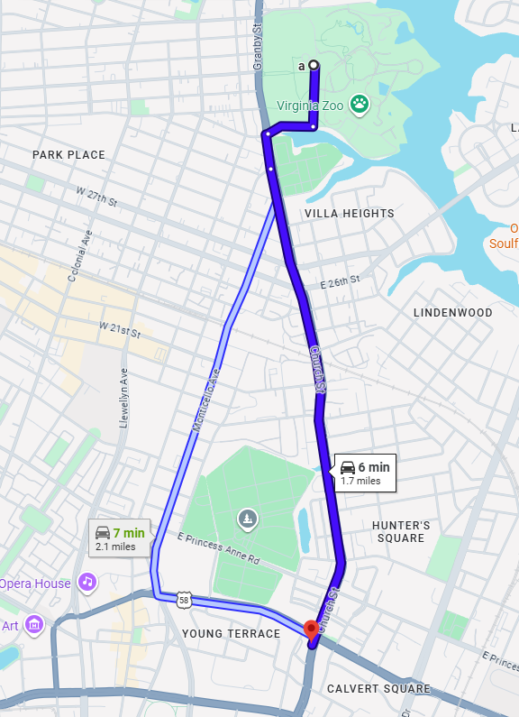

Route 1 cont.
Directions of the route:
Start: 635 E Virginia Beach Blvd, Norfolk, VA 23504
End: Popeyes Louisiana Kitchen, 300 St Pauls Blvd, Norfolk, VA 23510
Time to Destination: 5 min
Distance: 0.6 miles
- Starting at 635 E Virginia Beach Blvd, Norfolk, VA 23504 proceed on Church Street for 0.3 miles
- Church Street will become Fenchurch Street and continue ahead for another 0.3 miles
- The end of the route is at the end of Fenchurch Street, turning onto the exit to St.Paul’s Blvd
- At the end of the route deactivate the GoPro and proceed to the next route
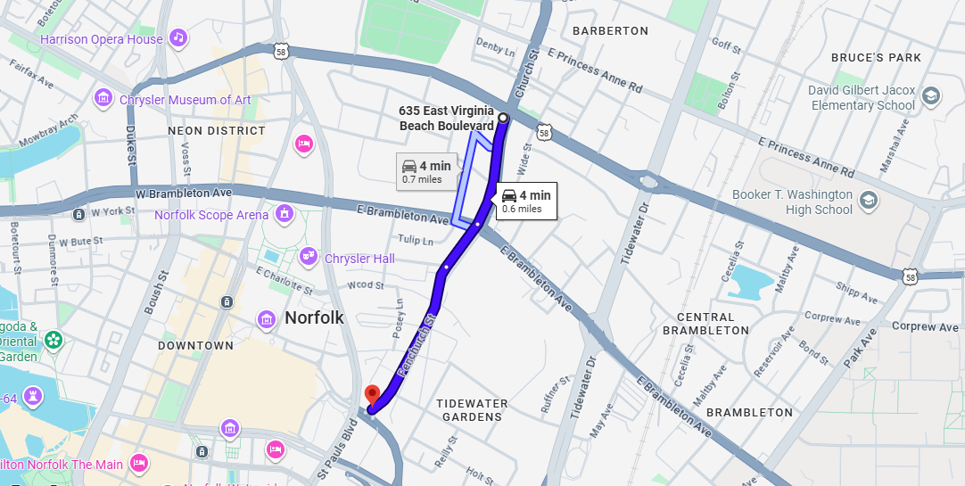

Route 2
Directions to the route:
Start: Popeyes Louisiana Kitchen, 300 St Pauls Blvd, Norfolk, VA 23510
End: 539 State St, Norfolk, VA 23523
Time to Destination: 5 min
Distance: 1.4 miles
- From Fenchurch Street and the exit take a left onto Saint Paul’s Blvd.
- Continue on St.Paul’s Blvd and take a left onto City Hall Ave.
- Take the exit to West 264/464 to Portsmouth.
- Merge onto 264 west bound and take the exit on the left to Berkeley Ave.
- At the light take a left onto Berkeley Avenue
- Continue on Berkeley for 0.1 miles
- Before State Street please activate Go Pro, reduce speed and activate hazard lights.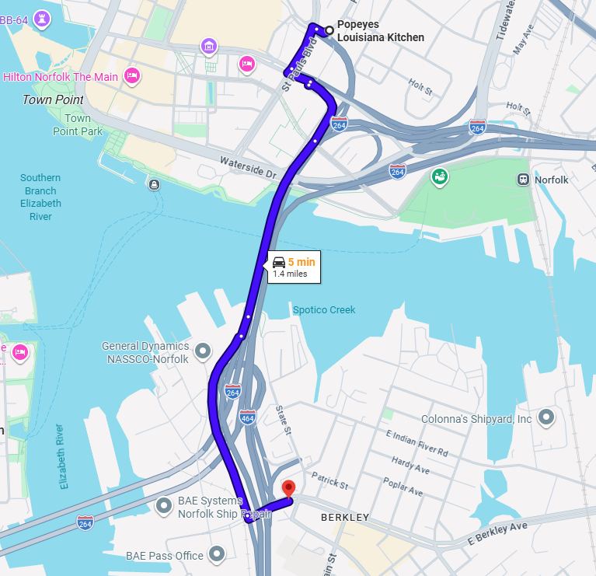

Route 2 cont.
Directions of the route:
Start: 539 State St, Norfolk, VA 23523
End: 600 E Fairview Rd, Chesapeake, VA 23325
Time to Destination: 8 min
Distance: 0.8 miles
- Starting at 539 State St, Norfolk, VA 23523 continue on Berkeley Ave for 0.8 miles until reaching Marsh Street on the Right
- Marsh Street is the point at which this route ends
- At the end of the route deactivate the GoPro and proceed to the next route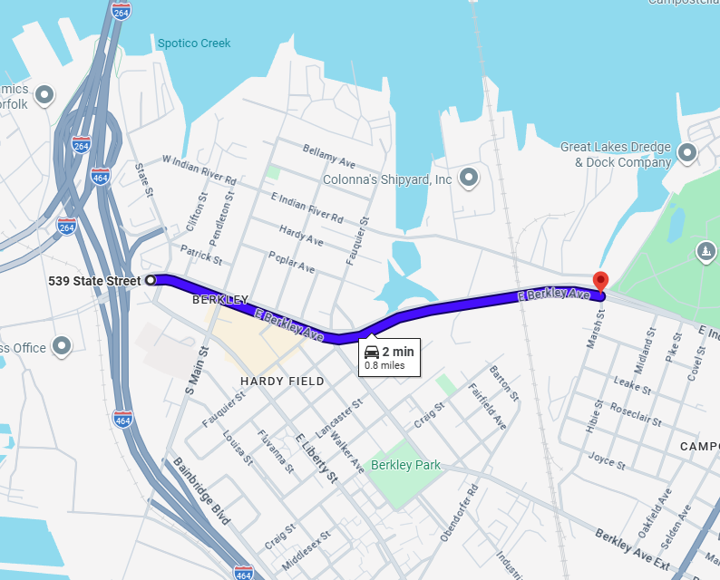

Route 3
Directions to the route:
Start: 600 E Fairview Rd, Chesapeake, VA 23325
End: 1543 Vine St, Norfolk, VA 23523
Time to Destination: 3 min
Distance: 0.9 miles
- Starting at 600 E Fairview Rd, Chesapeake, VA 23325 continue onto Berkeley Ave which will become E Indian River Road.
- Take a right onto Wilson Rd heading south towards Chesapeake for 0.4 miles.
- Take a left onto Manson Street and continue straight for 0.1 miles.
- Take a left onto Isaac Street and immediately take a left onto Vine Street.
- The route begins when you turn onto Vine Street.
- Please activate Go Pro, reduce speed and activate hazard lights.
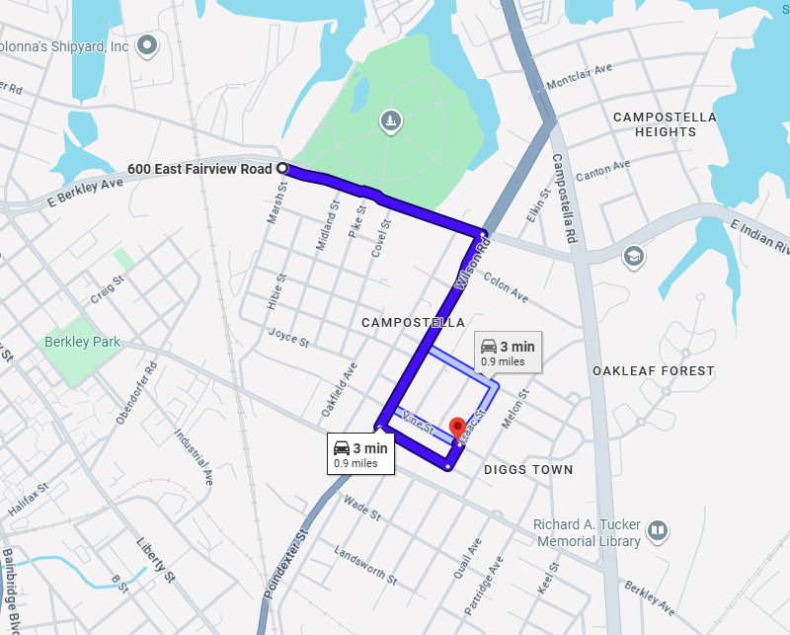
Route 3 cont.
Directions of the route:
Start: 1543 Vine St, Norfolk, VA 23523
End: 909 Campostella Rd, Norfolk, VA 23523
Time to Destination: 8 min
Distance: 0.8 miles
- Starting at 1543 Vine St, Norfolk, VA 23523 continue and take a right onto Delevan St.
- At the end of Delevan St take a left onto Cypress Street.
- Continue on Cypress Street until the stop sign and take a right onto Wilson Rd.
- Continue on Wilson Road for 0.2 miles and take a right at the light onto Indian River Road and get into the left lane almost immediately.
- Almost immediately after getting onto Indian River Road take the first left onto Elkin Street.
- Continue on Elkin Street for 0.2 miles and take a right onto Campostella Road
- After turning onto Campostella Road the end of the route is just ahead.
- deactivate the GoPro and proceed to the next route.
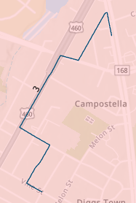
Route 4
Directions to the route:
Start: 909 Campostella Rd, Norfolk, VA 23523
End: Fortis College in Norfolk, 6300 Center Dr Bldg 22, Norfolk, VA 23502
Time to Destination: 11 min
Distance: 6.5 miles
- Starting at 909 Campostella Rd, Norfolk, VA 23523 continue on Campostella for 0.1 miles and take a right onto E Indian River Road.
- Continue on Indian River Road for 0.2 miles and take a right onto Wilson Road.
- Continue on Wilson Road for 0.2 miles and take a left onto Campostella Road.
- Continue on Campostella Road for 0.8 miles across the Campostella Bridge.
- Take the exit onto East 264 to Viriginia Beach.
- Take 264 for approximately 2.2 miles and take the I-64 Military Hwy, Chesapeake and Newtown Road exit to exits 13-14-15.
- Continue for another 1.1 miles to exit 15A to Newtown Road South.
- Get into the right most turn lane and turn onto Newtown Road South.
- Continue onto Newtown Road for 0.2 miles and take a right onto Kempsville Road.
- Continue on Kempsville Road for 0.4 miles and the route will start after passing Center Drive.
- please activate Go Pro, reduce speed and activate hazard lights.
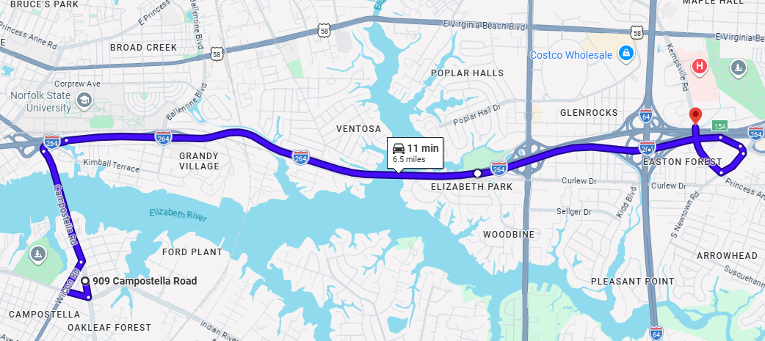

Route 4 cont.
Directions of the route:
Start: Fortis College in Norfolk, 6300 Center Dr Bldg 22, Norfolk, VA 23502
End: 995 Kempsville Rd, Norfolk, VA 23502
Time to Destination: 5 min
Distance: 0.6 miles
- Starting at Fortis College in Norfolk, 6300 Center Dr Bldg 22, Norfolk, VA 23502 continue on Kempsville Rd for 0.6 miles.
- The end of the route is at the intersection of E Virginia Beach Blvd.
- You will want to move from the right lane into the left lane towards the end of the route.
- Do not worry about getting to the end of the route, safely merge across to get into the left turn lane to turn onto Viriginia Beach Blvd.
- deactivate the GoPro and proceed to the next route.
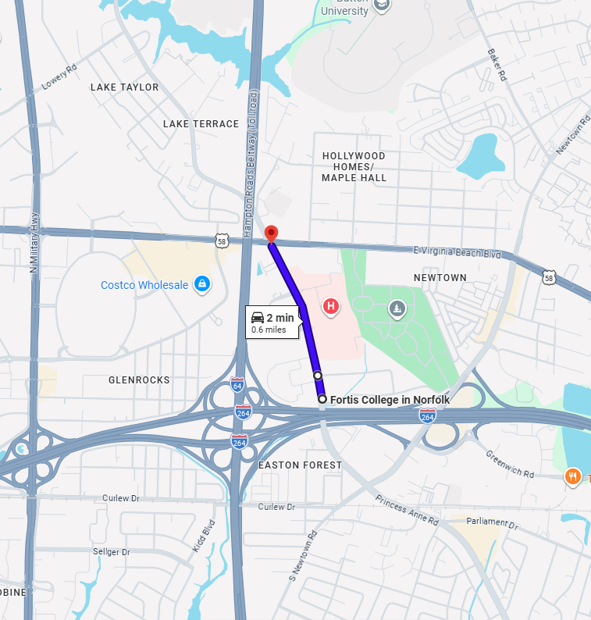
Route 5
Directions to the route:
Start: 995 Kempsville Rd, Norfolk, VA 23502
End: 5940 Benton St, Norfolk, VA 23502
Time to Destination: 3 min
Distance: 0.8 miles
- Starting at 995 Kempsville Rd, Norfolk, VA 23502 take a left onto Viriginia Beach Blvd
- Continue on Viriginia Beach Blvd briefly and get into the left lane turn lane for Poplar Hall Drive.
- Take a left onto Poplar Hall Drive.
- Continue on Polar Hall Drive for 0.5 miles.
- Take a left onto Hicks Ave.
- The route will begin after turning right onto Benton St.
- please activate Go Pro, reduce speed and activate hazard lights.
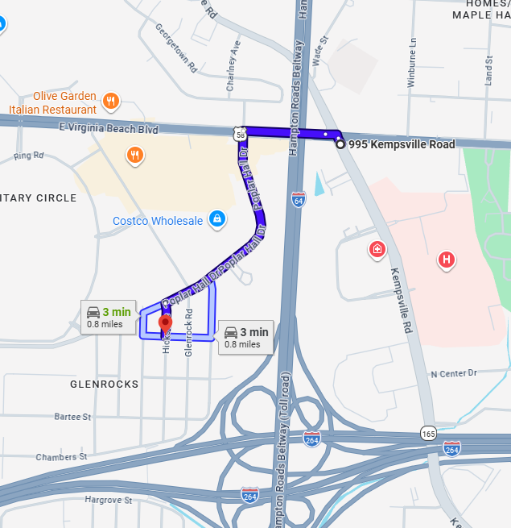
Route 5 cont.
Directions of the route:
Start: 5940 Benton St, Norfolk, VA 23502
End: 304 Wellman St, Norfolk, VA 23502
Time to Destination: 8 min
Distance: 0.8 miles
- Starting at 5940 Benton St, Norfolk, VA 23502 continue on Benton Street.
- Take a left on to Honaker Ave and continue for 0.2 miles.
- Take a right onto Bartee St and continue for 250 ft.
- Take a right onto Brockwell ave and continue for 500ft.
- Take a left onto Finney St. for 250ft and take a left onto Frizzell Ave.
- Continue on Frizzell Ave. for 0.2 miles and take a right onto Chambers St.
- Continue on Chambers Street for 0.2 miles, the route will end at Wellman Street.
- deactivate the GoPro and proceed to the next route. 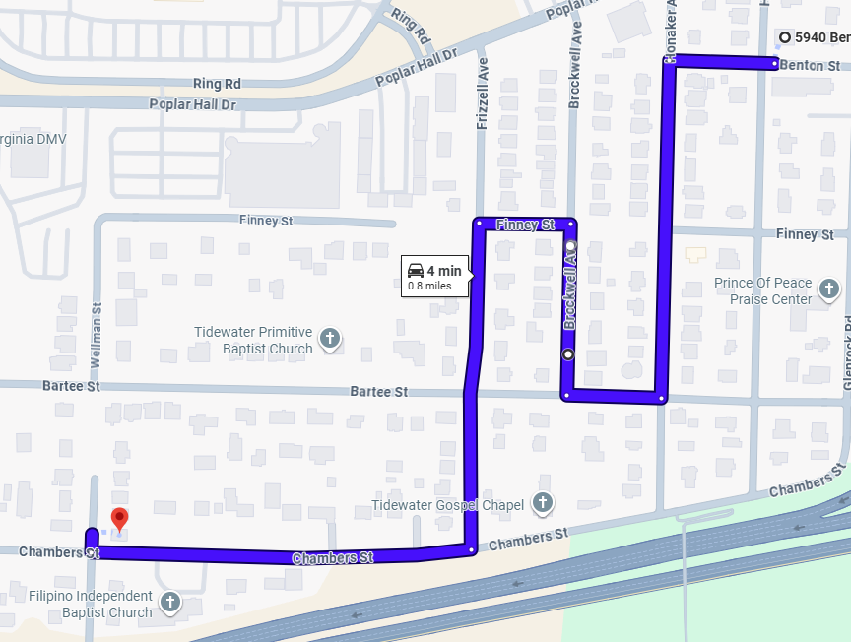
Route 6
Directions to the route:
Start: 304 Wellman St, Norfolk, VA 23502
End: 1135 Eastover Cir, Norfolk, VA 23502
Time to Destination: 7 min
Distance: 1.8 miles
- Starting at 304 Wellman St, Norfolk, VA 2350 continue on Chambers St which becomes Military Hwy.
- Get into the Right lane to turn right onto US-13 (Military Highway).
- Continue on N Military Highway for 0.4 miles and merge right for the exit to turn left onto Virginia Beach Blvd.
- Stay in the left turn lane closest to the right, so that you have an easier time merging right once on Virginia Beach Blvd.
- Continue on Viriginia Beach Blvd merging right for 0.6 miles.
- Turn right onto Raby Road and in 350 ft turn left onto Pleasant Valley Rd.
- Continue on Pleasant Valley Rd for 0.2 miles.
- Take a left onto Coach Way Dr until Eastover Circle this is where the route begins.
- please activate Go Pro, reduce speed and activate hazard lights.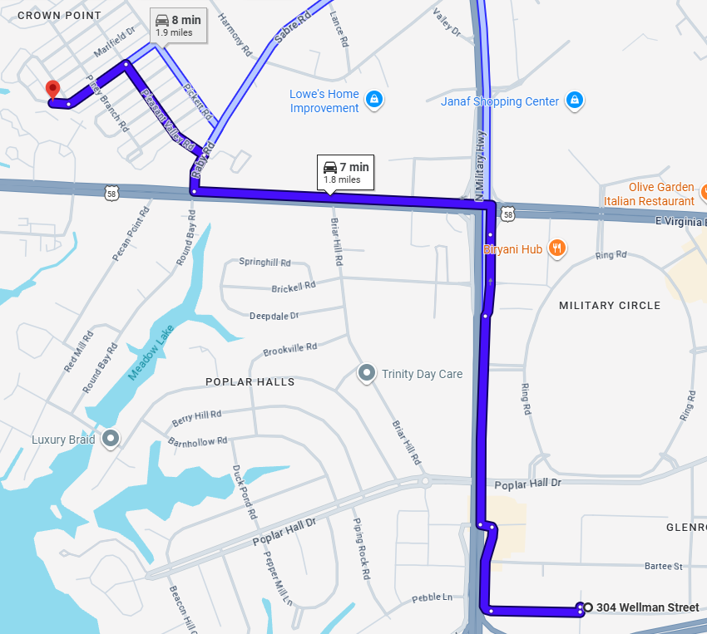
Route 6 cont.
Directions of the route:
Start: 1135 Eastover Cir, Norfolk, VA 23502
End: Interstate All Battery Center of Norfolk, VA, 5568 Sabre Rd, Norfolk, VA 23502
Time to Destination: 7 min
Distance: 0.7 miles
- Starting at 1135 Eastover Cir, Norfolk, VA 23502 proceed around the Circle which will become Eastover Rd.
- Take a left on Bellefield Rd and continue for 300 ft and take a left onto Piney Branch.
- Take the next right into the alley follow the alley and continue onto Quill Road directly ahead.
- Continue on Quill Road for 0.1 miles and take a right onto Harmony Rd.
- Continue on Harmony Road for 0.3 miles.
- The end of the route is at the end of harmony rd at the intersection with Sabre Rd/Raby Road.
- Prepare to turn right onto Sabre Road/Raby Road.
- deactivate the GoPro and proceed to the next route.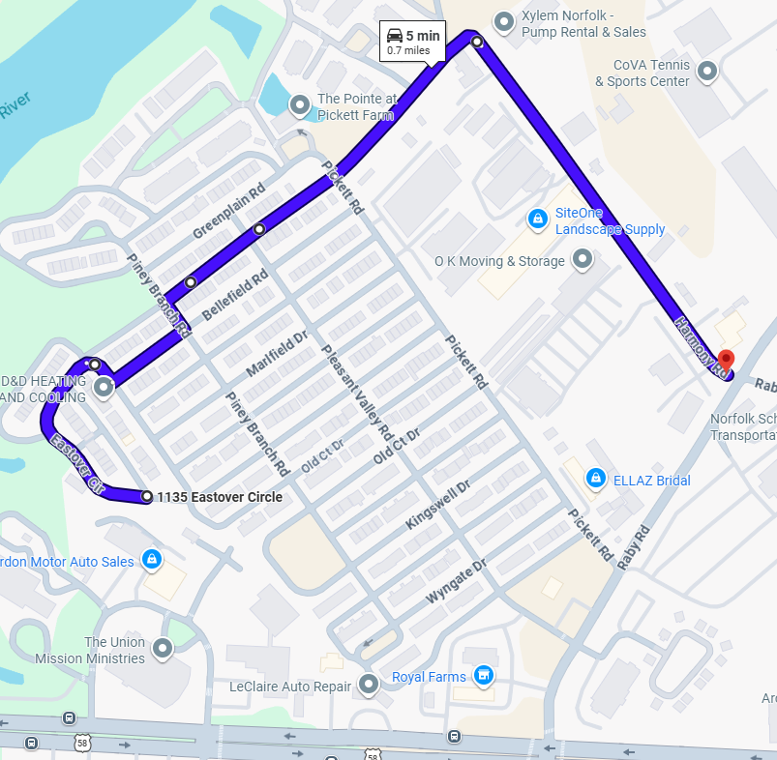
Route 7
Directions to the route:
Start: Interstate All Battery Center of Norfolk, VA, 5568 Sabre Rd, Norfolk, VA 23502
End: 3026 VA-166, Norfolk, VA 23504
Time to Destination: 7 min
Distance: 2.5 miles
- Starting at Interstate All Battery Center of Norfolk, VA, 5568 Sabre Rd, Norfolk, VA 23502 turn right onto Raby Road.
- Continue on Raby Road for 0.3 miles and turn right onto Virginia Beach Blvd.
- Continue on Virginia Beach Blvd for 1.2 miles and turn right onto Ingleside road.
- Continue on Ingleside Road for 0.6 miles and turn left onto E Princess Anne Road.
- Continue on E Princess Anne Road for 0.4 miles.
- The route will begin on Princess Anne Road after passing Ballentine Blvd.
- please activate Go Pro, reduce speed and activate hazard lights.
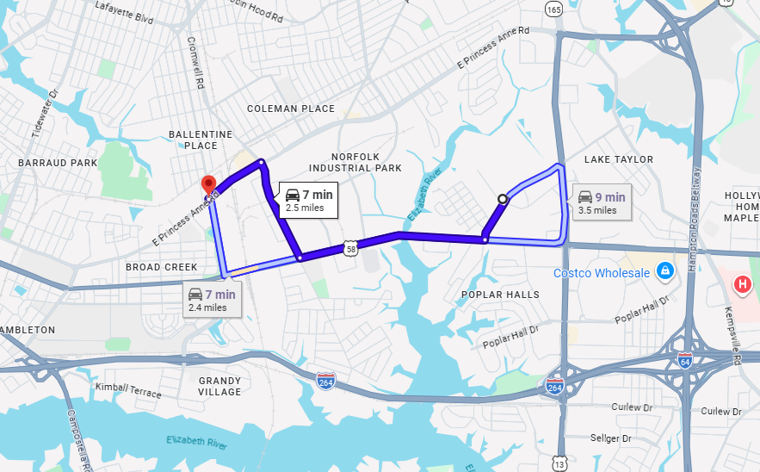

Route 7 cont.
Directions of the route:
Start: 3026 VA-166, Norfolk, VA 23504
End: Princess Anne & Rainey, Norfolk, VA 23504
Time to Destination: 8 min
Distance: 0.8 miles
- Starting at 3026 VA-166, Norfolk, VA 23504 continue on Princess Anne Road for 0.8 miles.
- The route will end at Rainey Drive on the left and before Citgo on the right.
- Prepare to U-turn on Princess Anne Road to proceed to the next route.
- deactivate the GoPro and proceed to the next route.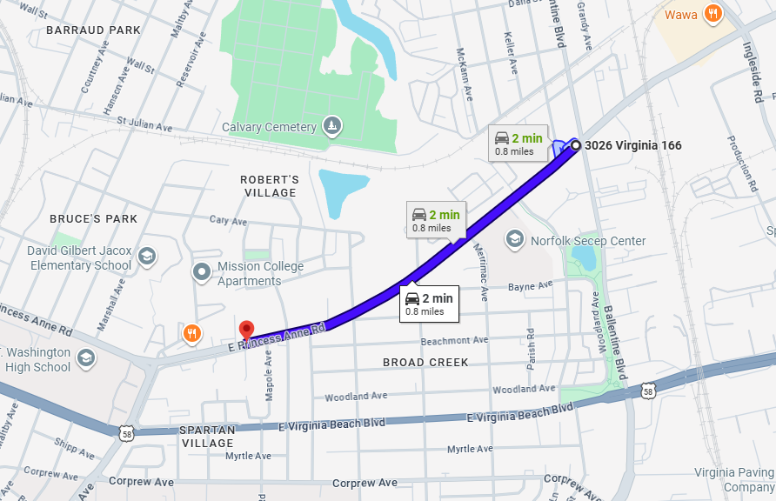

Route 8
Directions to the route:
Start: Princess Anne & Rainey, Norfolk, VA 23504
End: 3026 VA-166, Norfolk, VA 23504
Time to Destination: 5 min
Distance: 1.9 miles
- Starting at Princess Anne & Rainey, Norfolk, VA 23504 make a U-turn on Princess Anne Road and begin heading east for 0.8 miles.
- Turn left onto Ballentine Blvd and continue for 0.5 miles.
- Turn left onto Tait Terrace. (It is at the first light on Ballentine).
- Continue on Tait Terrace for 0.5 miles.
- The route will begin after passing Chesapeake blvd.
- please activate Go Pro, reduce speed and activate hazard lights.
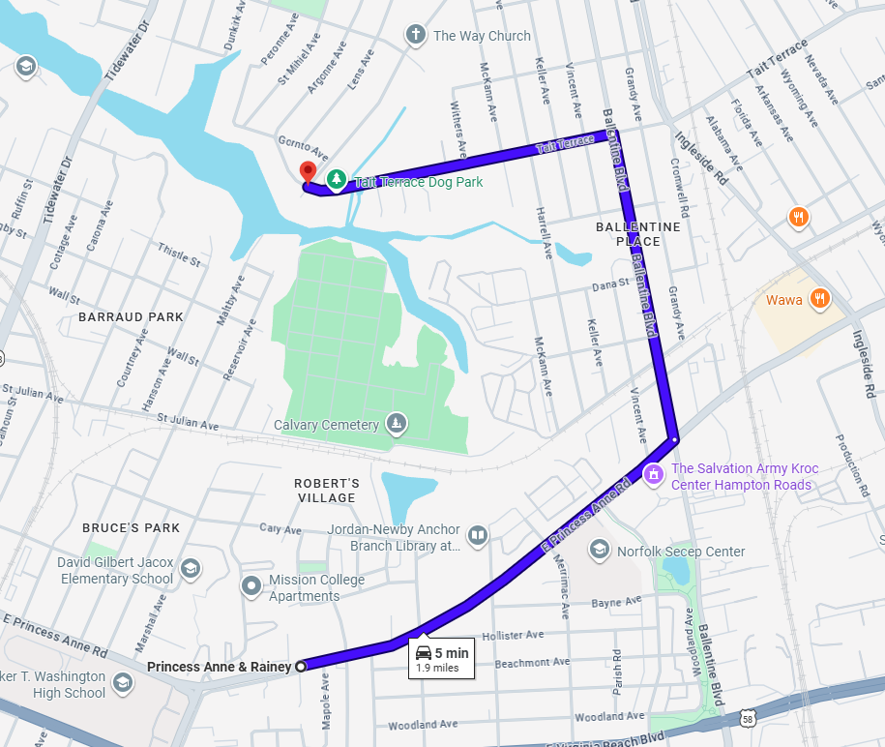
Route 8 cont.
Directions of the route:
Start: 2510 Chesapeake Blvd, Norfolk, VA 23509
End: Princess Anne & Rainey, Norfolk, VA 23504
Time to Destination: 8 min
Distance: 0.8 miles
- Starting at 2510 Chesapeake Blvd, Norfolk, VA 23509 continue on Tait Terrace for 0.1 miles.
- Turn left to stay on Tait Terrace which will become Bapaume and then Peronne ave. Stay on this road for approximately 0.4 miles.
- Take a right onto Shoop Ave. and take the first left onto St Mihiel Ave.
- Continue on St Mihiel Ave. for 0.1 miles and take a left onto Pope Ave.
- Take the first right onto Peronne Ave. and continue on Perrone for 0.2 miles.
- The route ends at the midpoint between St.Denis Ave and the next street Bellevue Ave.
- deactivate the GoPro and proceed to the next route.
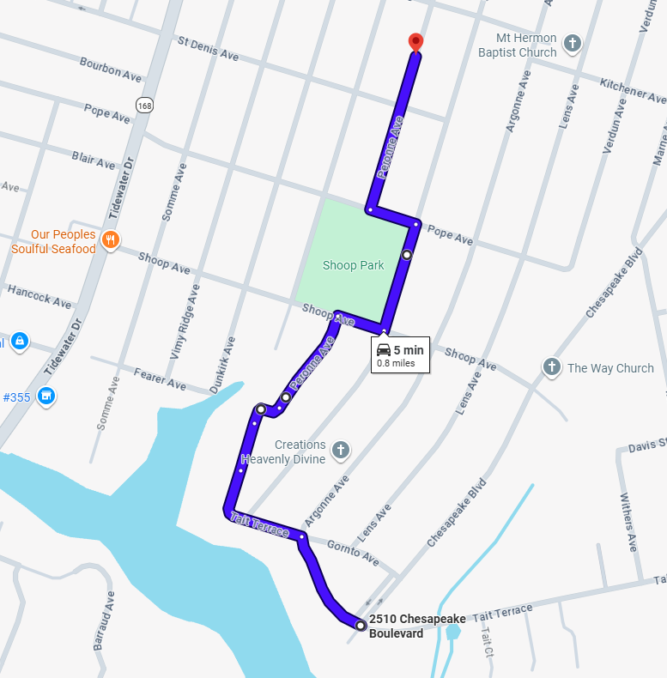
Route 9
Directions to the route:
Start: 3016 Peronne Ave, Norfolk, VA 23509
End: 3900 Robin Hood Rd, Norfolk, VA 23513
Time to Destination: 6 min
Distance: 1.4 miles
- Starting at 3016 Peronne Ave, Norfolk, VA 23509 continue Peronne Ave. for 0.2 miles and turn right onto Lafayette Blvd.
- Continue on Lafayette Blvd for 0.3 miles and get into the left turn lane for Chesapeake Blvd before taking an immediate right back onto Lafayette Blvd.
- Continue on Lafayette Blvd for another 0.3 miles.
- Turn right on Oklahoma Ave. and in 400ft take the first left onto Atterbury St.
- Continue on Atterbury St. for 0.4 miles and take a left onto Birch Street.
- The route will begin Immediately after turning left onto Robin Hood Rd.
- please activate Go Pro, reduce speed and activate hazard lights.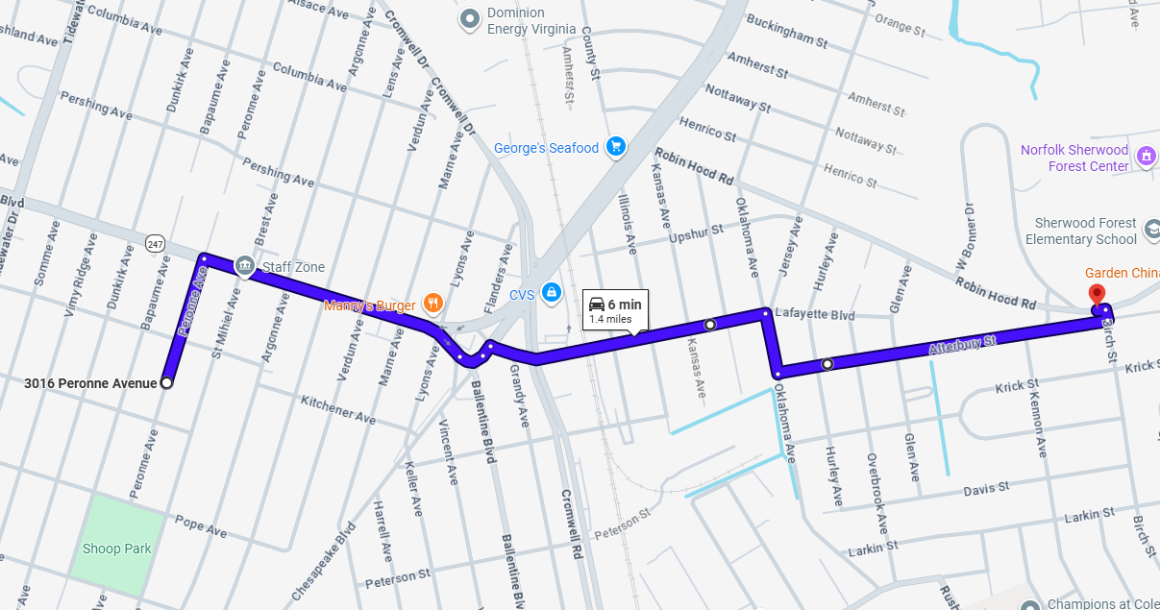

Route 9 cont.
Directions of the route:
Start: 3900 Robin Hood Rd, Norfolk, VA 23513
End: 3600 Robin Hood Rd, Norfolk, VA 23513
Time to Destination: 6 min
Distance: 0.6 miles
- Starting at 3900 Robin Hood Rd, Norfolk, VA 23513 continue on Robin Hood Rd for 0.6 miles.
- The route ends at the intersection with Chesapeake Blvd at the light.
- Prepare to take a right onto Chesapeake to proceed to the next route.
- deactivate the GoPro and proceed to the next route.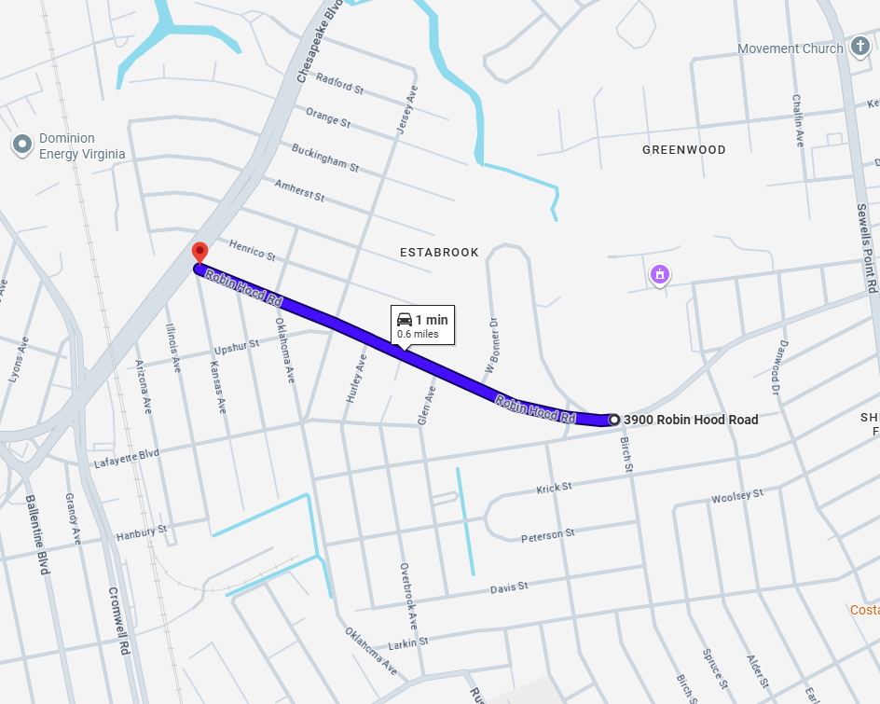

Route 10
Directions to the route:
Start: 3600 Robin Hood Rd, Norfolk, VA 23513
End: 3601 Orange St, Norfolk, VA 23513
Time to Destination: 1 min
Distance: 0.3 miles
- Starting at 3600 Robin Hood Rd, Norfolk, VA 23513 take a right onto Chesapeake Blvd and continue on Chesapeake Blvd for 0.3 miles.
- The route will begin after passing Orange Street on the right. (You will pass four streets on the right before you reach Orange Street).
- please activate Go Pro, reduce speed and activate hazard lights.
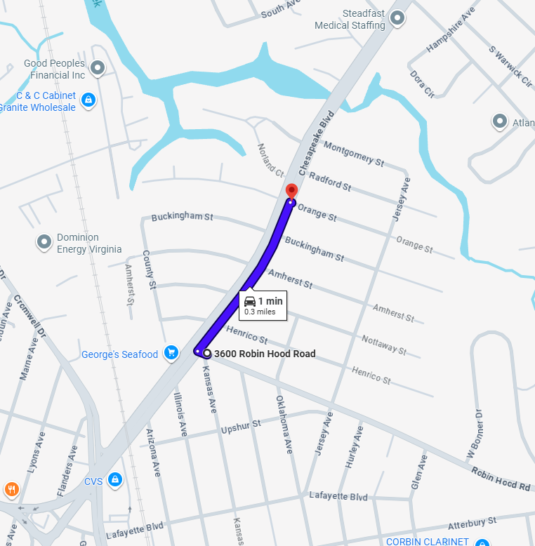

Route 10 cont.
Directions of the route:
Start: 3601 Orange St, Norfolk, VA 23513
End: Chesapeake & Norview, Norfolk, VA 23513
Time to Destination: 7 min
Distance: 0.7 miles
- Starting at 3601 Orange St, Norfolk, VA 23513 continue on Chesapeake Blvd for 0.7 miles.
- The route will end before the intersection with Norview Ave and Sewells Point Rd.
- Get into the left turn lane at this intersection preparing to turn onto Sewells Point Road.
- deactivate the GoPro and proceed to the next route.
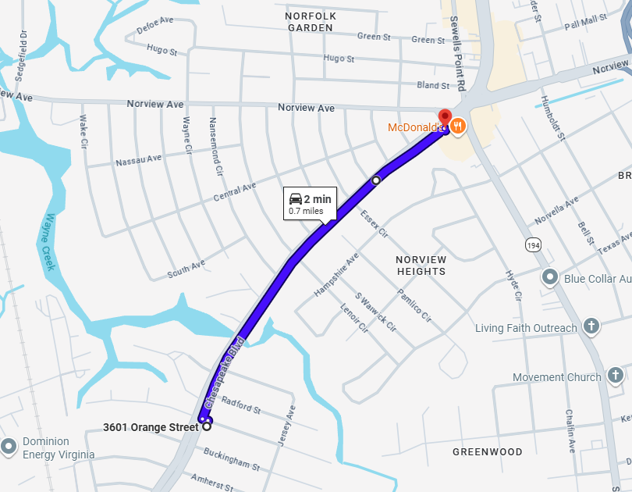
Route 11
Directions to the route:
Start: Chesapeake & Norview, Norfolk, VA 23513
End: 6130 Sewells Point Rd, Norfolk, VA 23513
Time to Destination: 2 min
Distance: 0.1 miles
- Starting at Chesapeake & Norview, Norfolk, VA 23513 take a left from Chesapeake Blvd to Sewells Point Road.
- After turning onto Sewells Point Road, the route will begin at the first set of buildings on the right.
- please activate Go Pro, reduce speed and activate hazard lights.
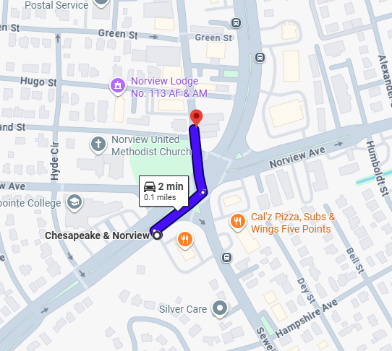

Route 11 cont.
Directions of the route:
Start: 6130 Sewells Point Rd, Norfolk, VA 23513
End: BEB Automotive, 6907 Sewells Point Rd, Norfolk, VA 23513
Time to Destination: 9 min
Distance: 0.9 miles
- Starting at 6130 Sewells Point Rd, Norfolk, VA 23513 continue on Sewells Point Road for 0.9 miles.
- The route ends before the I-64 overpass at BEB Automotive.
- deactivate the GoPro and proceed to the next route.
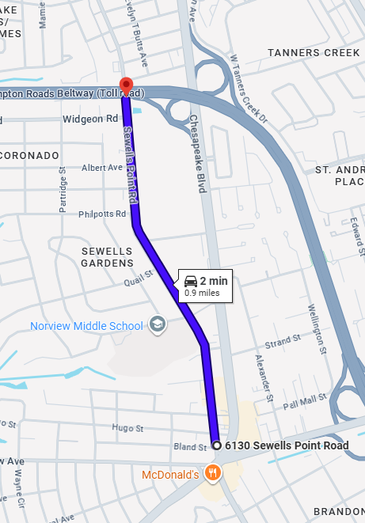
Route 12
Directions to the route:
Start: BEB Automotive, 6907 Sewells Point Rd, Norfolk, VA 23513
End: 975 E Little Creek Rd, Norfolk, VA 23518
Time to Destination: 4 min
Distance: 1.5 miles
- Starting at BEB Automotive, 6907 Sewells Point Rd, Norfolk, VA 23513 take Sewells Point Road for 1 mile and turn right onto E Little Creek Rd.
- Continue on Little Creek Road for 0.5 miles
- Turn right onto Chesapeake Blvd, the route will begin after turning onto Chesapeake Blvd.
- please activate Go Pro, reduce speed and activate hazard lights.
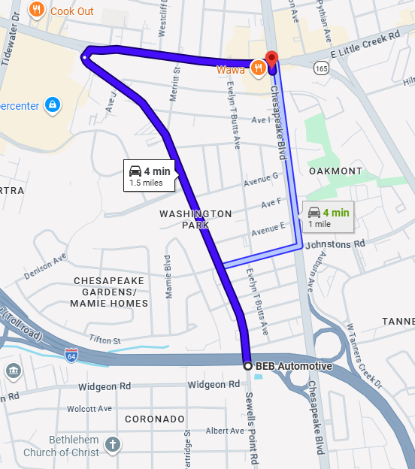
Route 12 cont.
Directions of the route:
Start: 975 E Little Creek Rd, Norfolk, VA 23518
End: 1059 Johnstons Rd, Norfolk, VA 23513
Time to Destination: 9 min
Distance: 0.9 miles
- Starting at 975 E Little Creek Rd, Norfolk, VA 23518 take Chesapeake Blvd for 0.2 miles and take a right on Avenue H.
- Continue on Avenue H for 0.1 miles and take the second left onto Evelyn T Butts Avenue.
- Continue on Evelyn T Butts Avenue for 0.1 miles and take a left on Avenue G.
- Continue on Avenue G for 0.1 miles and take a right back onto Chesapeake Blvd.
- Continue on Chesapeake Blvd for 0.2 miles and take the third right onto Johnstons Road.
- The route ends before the first right onto Evelyn T Butts Avenue.
- Prepare to turn around on Johnston Road to proceed to the next route.
- deactivate the GoPro and proceed to the next route.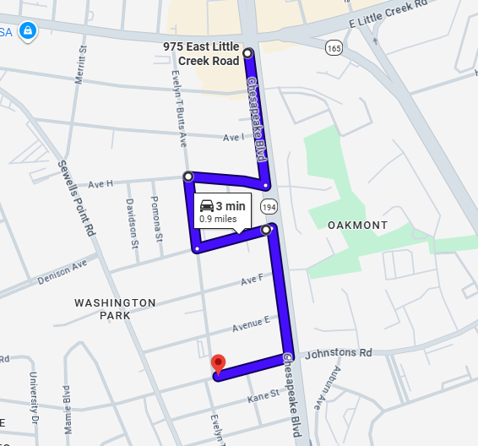
Route 13
Directions to the route:
Start: 1059 Johnstons Rd, Norfolk, VA 23513
End: Hardee's, 2301 E Little Creek Rd, Norfolk, VA 23518
Time to Destination: 5 min
Distance: 1.4 miles
- Starting at 1059 Johnstons Rd, Norfolk, VA 23513 take Johnston Road toward Chesapeake Blvd.
- Continue on Johnstons Road which becomes Halprin Drive for 1.4 miles.
- After taking a right on E Little Creek Road the route will begin.
- please activate Go Pro, reduce speed and activate hazard lights.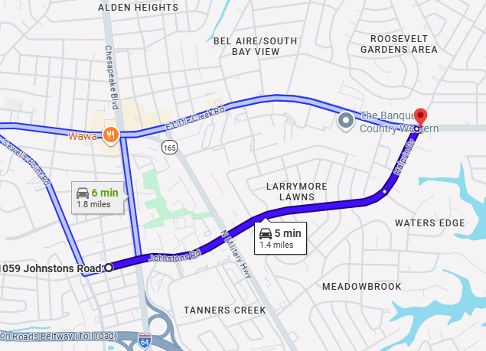

Route 13 cont.
Directions of the route:
Start: Hardee's, 2301 E Little Creek Rd, Norfolk, VA 23518
End: 7-Eleven, 2475 E Little Creek Rd, Norfolk, VA 23518
Time to Destination: 5 min
Distance: 0.5 miles
- Starting at Hardee's, 2301 E Little Creek Rd, Norfolk, VA 23518 travel on E Little Creek Rd for 0.5 miles.
- The route ends at the road after the 7-Eleven, Azalea Garden Road.
- Prepare to turn right on Azalea Garden Road.
- deactivate the GoPro and proceed to the next route.
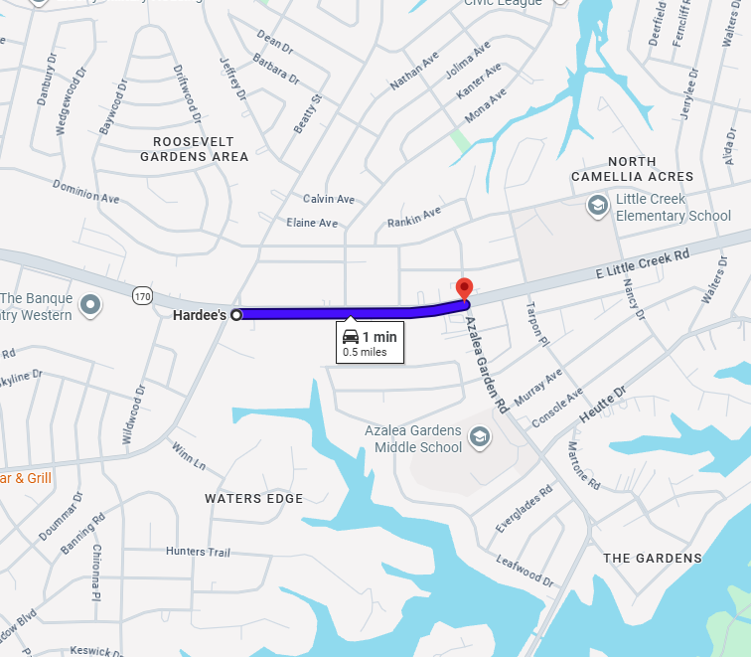
Route 14
Directions to the route:
Start: 7-Eleven, 2475 E Little Creek Rd, Norfolk, VA 23518
End: 2751 Console Ave, Norfolk, VA 23518
Time to Destination: 2 min
Distance: 0.6 miles
- Starting at 7-Eleven, 2475 E Little Creek Rd, Norfolk, VA 23518 turn on Azalea Garden Road for 0.3 miles.
- Take a left onto Heutte Drive and continue for 0.3 miles.
- Take a left onto Nancy Dr and take the first left onto Console ave.
- After the first two houses the route begins.
- please activate Go Pro, reduce speed and activate hazard lights.
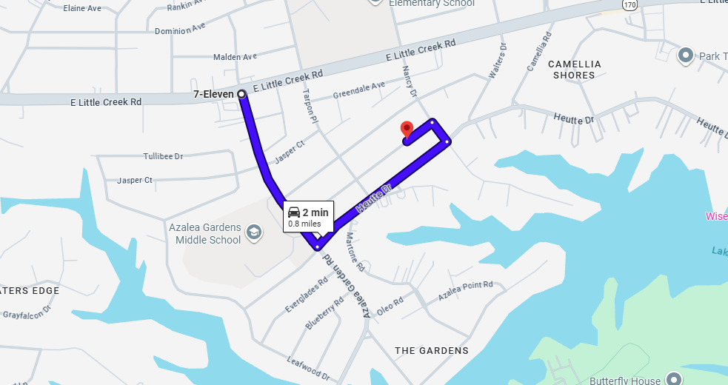

Route 14 cont.
Directions of the route:
Start: 2751 Console Ave, Norfolk, VA 23518
End: 7830 Walters Dr, Norfolk, VA 23518
Time to Destination: 6 min
Distance: 0.6 miles
- Starting at 2751 Console Ave, Norfolk, VA 23518 continue on Console Ave for 0.1 miles and take a right onto Tarpon Pl.
- Continue on Tarpon Pl for 300 ft and take the first right onto Murray Ave.
- Continue on Murray Ave. for 0.3 miles and take the second left onto Walters Drive.
- The end of the route is at the intersection with Little Creek Rd and Walters Drive.
- Prepare to turn right on Little Creek Rd to proceed to the next route.
- deactivate the GoPro and proceed to the next route.
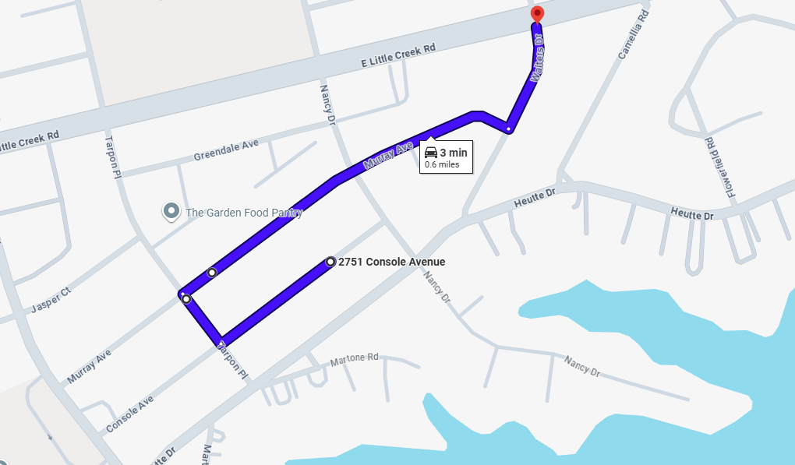

Route 15
Directions to the route:
Start: 7830 Walters Dr, Norfolk, VA 23518
End: 3650 E Ocean View Ave, Norfolk, VA 23518
Time to Destination: 4 min
Distance: 1.7 miles
- Starting at 7830 Walters Dr, Norfolk, VA 23518 take a right onto Little Creek Road and continue on it for 0.6 miles
- Take a left at the third light onto Shore Dr.
- Continue on Shore Drive for 0.9 miles.
- Pay attention to the street signs and look for the 17th Bay Street sign.
- The route will begin after passing 17th Bay Street.
- please activate Go Pro, reduce speed and activate hazard lights.
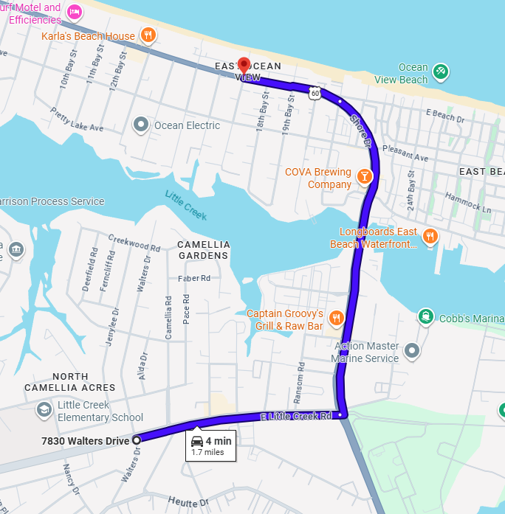
Route 15 cont.
Directions of the route:
Start: 3650 E Ocean View Ave, Norfolk, VA 23518
End: 2648 E Ocean View Ave, Norfolk, VA 23518
Time to Destination: 7 min
Distance: 0.7 miles
- Starting at 3650 E Ocean View Ave, Norfolk, VA 23518, continue on Shore Drive for 0.7 miles.
- The route ends after passing 7th Bay Street.
- deactivate the GoPro and proceed to the next route.
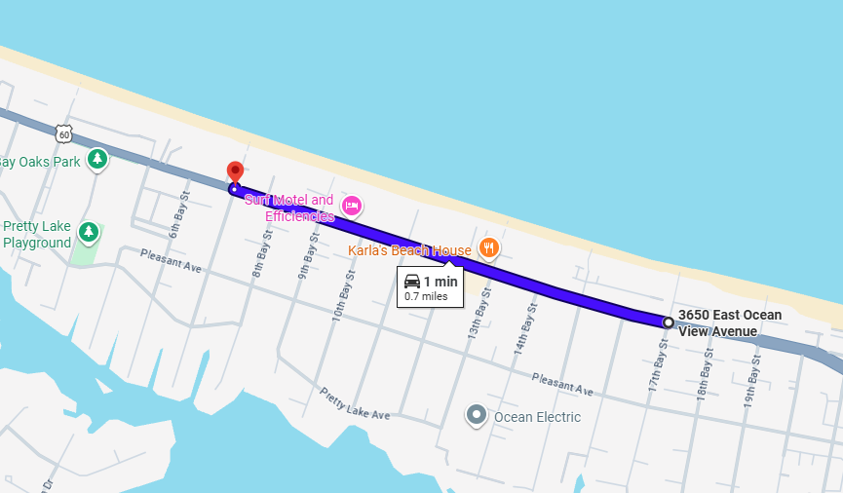

Route 16
Directions to the route:
Start: 2648 E Ocean View Ave, Norfolk, VA 23518
End: Ocean View & Willow, Norfolk, VA 23503
Time to Destination: 3 min
Distance: 1.3 miles
- Starting at 2648 E Ocean View Ave, Norfolk, VA 23518 continue on Shore Drive for 1.3 miles.
- The route will begin after turning left onto Willow Terrace. (There are no landmarks to indicate where this left turn is, it is a small alley and can be easily missed.)
- please activate Go Pro, reduce speed and activate hazard lights.
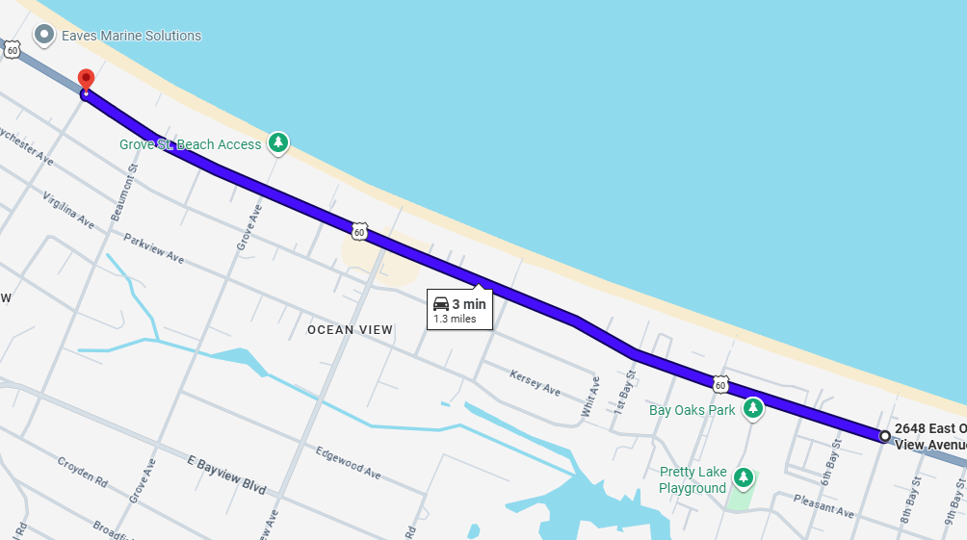
Route 16 cont.
Directions of the route:
Start: 36 Ocean View & Willow, Norfolk, VA 23503
End: 9400 Sturgis St, Norfolk, VA 23503
Time to Destination: 8 min
Distance: 0.8 miles
- Starting at 36 Ocean View & Willow, Norfolk, VA 23503 take a left onto Willow Terrace.
- Continue on Willow Terrace for 0.1 miles and take a left on Baychester Ave.
- Continue on Baychester Ave for 0.1 miles and take a right on Beaumont Street.
- Continue on Beaumont Street for 250 feet and take a right on Virgilinia Ave.
- Continue on Virgilina Ave for 0.1 miles and take a left onto Willow Terrace.
- Continue on Willow Terrace for 250 feet and take a right onto Simpson Court.
- Simpson Court will become Willow Court. Continue for 0.1 miles and take a right onto Modoc Ave.
- Continue on Modoc Ave for 300 ft and take a left onto Sturgis Street.
- The route will end at the intersection with Alfred Lane.
- deactivate the GoPro and proceed to the next route.
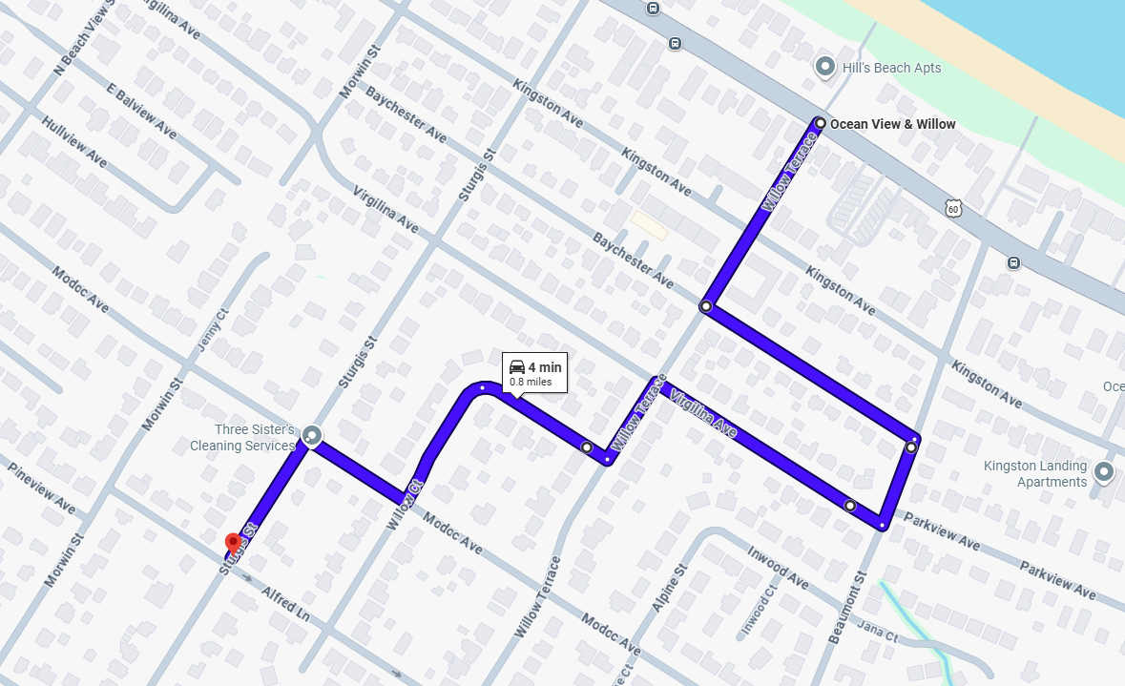
Route 17
Directions to the route:
Start: 9400 Sturgis St, Norfolk, VA 23503
End: 8500 Chesapeake Blvd, Norfolk, VA 23503
Time to Destination: 3 min
Distance: 0.8 miles
- Starting at 9400 Sturgis St, Norfolk, VA 23503 continue on Strugis Street for 0.3 miles.
- Take a left onto E Bayview Blvd and almost immediately take a right onto Sturgis Street.
- Continue on Sturgis Street for 0.1 miles and take a right on Fishermans Road.
- Continue on Fishermans Road for 0.8 miles.
- The route will begin after you take a right onto Chesapeake Blvd.
- please activate Go Pro, reduce speed and activate hazard lights.
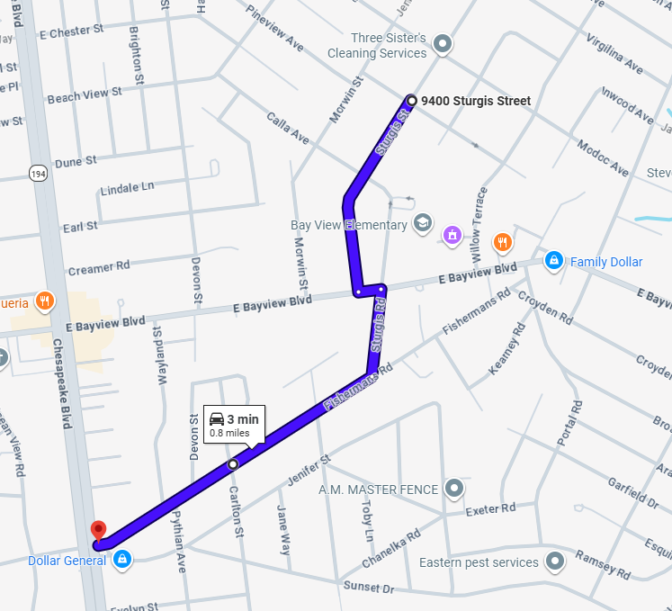
Route 17 cont.
Directions of the route:
Start: 8500 Chesapeake Blvd, Norfolk, VA 23503
End: 1300 E Bayview Blvd, Norfolk, VA 23503
Time to Destination: 5 min
Distance: 0.5 miles
- Starting at 8500 Chesapeake Blvd, Norfolk, VA 23503 Take a right onto Chesapeake Blvd from Fishermans Road.
- Continue On Chesapeake Blvd for 0.3 miles and take a right onto E Bayview Blvd at the light.
- Continue on E Bayview Blvd for 0.2 miles.
- The route will end after passing Devon Street on the left.
- deactivate the GoPro and proceed to the next route.
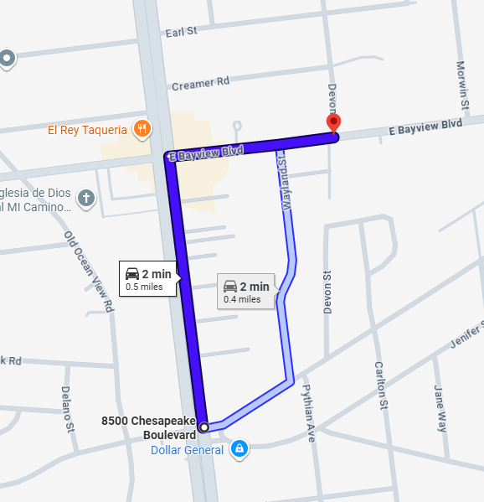
Route 18
Directions to the route:
Start: 1300 E Bayview Blvd, Norfolk, VA 23503
End: 100 E Ocean View Ave Apt 802, Norfolk, VA 23503
Time to Destination: 6 min
Distance: 2.2 miles
- Starting at 1300 E Bayview Blvd, Norfolk, VA 23503, take E Bayview Blvd for 0.2 miles and take a left onto Sturgis Street.
- Continue on Sturgis Street for 0.6 miles and take a left onto E Ocean View Ave.
- Continue on E Ocean View Ave for 1.3 miles.
- After passing the Mary D Pretlow Anchor Library the route will begin.
- please activate Go Pro, reduce speed and activate hazard lights.
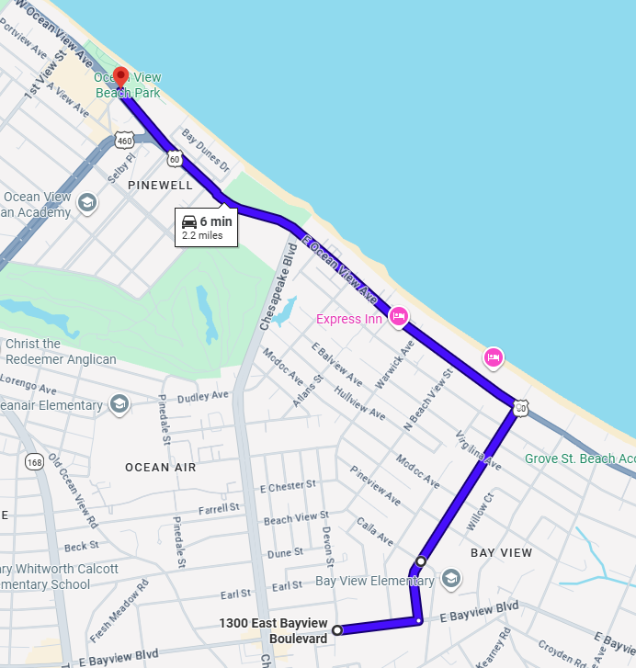
Route 18 cont.
Directions of the route:
Start: 100 E Ocean View Ave Apt 802, Norfolk, VA 23503
End: Ocean View Beach, 300 W Ocean View Ave, Norfolk, VA 23503
Time to Destination: 6 min
Distance: 0.6 miles
- Starting at 100 E Ocean View Ave Apt 802, Norfolk, VA 23503, Continue on E Ocean View Ave for 0.6 miles.
- The route will end after passing Tidewater Drive.
- deactivate the GoPro and proceed to the next route.
- Prepare to turn around on Ocean View Ave.
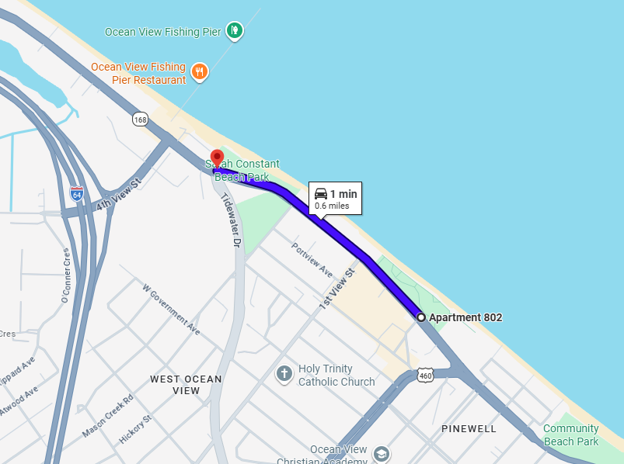

Route 19
Directions to the route:
Start: Ocean View Beach, 300 W Ocean View Ave, Norfolk, VA 23503
End: 272 E Bayview Blvd, Norfolk, VA 23503
Time to Destination: 5 min
Distance: 2.6 miles
- Starting at Ocean View Beach, 300 W Ocean View Ave, Norfolk, VA 23503 turn around on Ocean View Ave to begin heading East.
- Continue on Ocean View Ave. for 0.3 miles and turn right onto Tidewater Drive
- Continue on Tidewater Drive for 1.9 miles and turn right on E Bayview Blvd.
- Continue on E Bayview Blvd for 0.2 miles, the route will begin after passing Hammett Ave.
- please activate Go Pro, reduce speed and activate hazard lights.
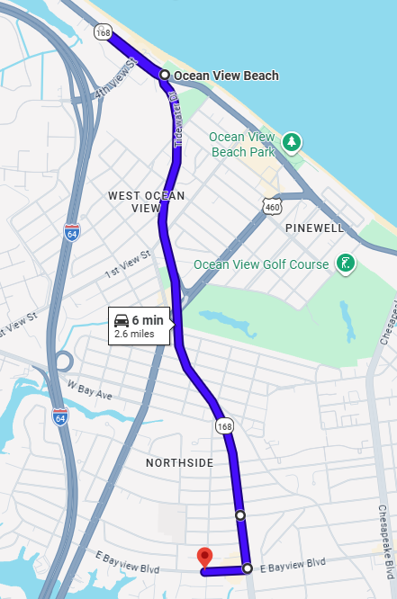

Route 19 cont.
Directions of the route:
Start: 272 E Bayview Blvd, Norfolk, VA 23503
End: 8856 Granby St, Norfolk, VA 23503
Time to Destination: 9 min
Distance: 0.9 miles
- Starting at 272 E Bayview Blvd, Norfolk, VA 23503 continue on E Bayview Blvd for 0.4 miles and turn right onto Granby Street.
- Continue on Granby Street for another 0.4 miles.
- The route will end before turning onto Chester Street, the fourth street on the right.
- Be prepared to turn right onto Chester Street to proceed to the next route.
- deactivate the GoPro and proceed to the next route.
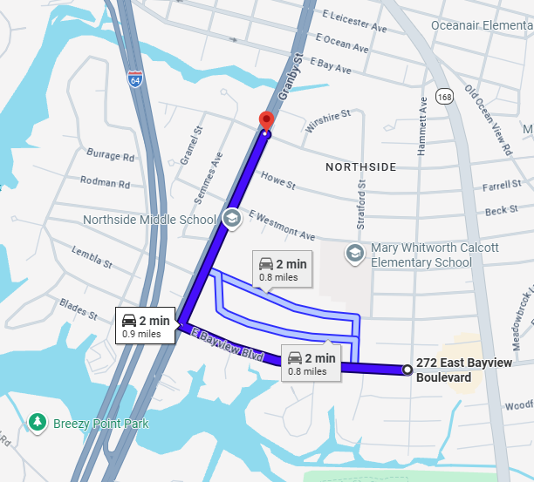
Route 20
Directions to the route:
Start: 8856 Granby St, Norfolk, VA 23503
End: 249 Forsythe St, Norfolk, VA 23505
Time to Destination: 8 min
Distance: 3.5 miles
- Starting at 8856 Granby St, Norfolk, VA 23503 take a right onto E Chester Street and continue on it for 0.4 miles.
- Turn right onto Tidewater Drive and continue on it for 2.3 miles.
- You will go under the I-64 overpass before turning right onto Thole Street.
- Continue on Thole Street for 0.8 miles.
- The route will begin before passing Norfolk Christian Schools on the left around Sue Lane on the right.
- please activate Go Pro, reduce speed and activate hazard lights.
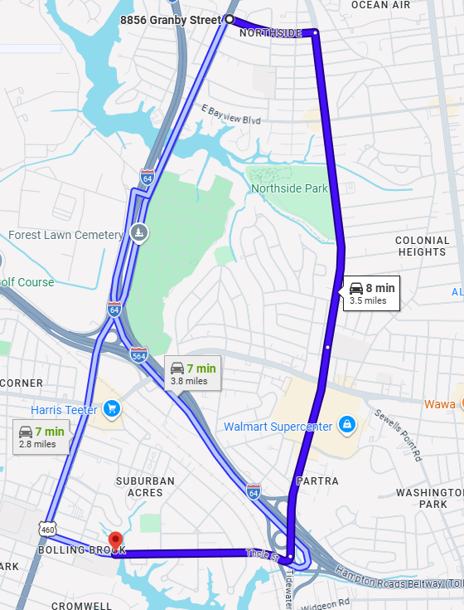
Route 20 cont.
Directions of the route:
Start: 249 Forsythe St, Norfolk, VA 23505
End: 7726 Granby St, Norfolk, VA 23505
Time to Destination: 11 min
Distance: 1.1 miles
- Starting at 249 Forsythe St, Norfolk, VA 23505 continue on Thole Street for 0.3 miles and Take a right onto Granby Street.
- Continue on Granby Street for 0.8 miles.
- The route will end before the I-564 Overpass.
- Prepare to turn right onto E Admiral Taussig Blvd.
- deactivate the GoPro and proceed to the next route.
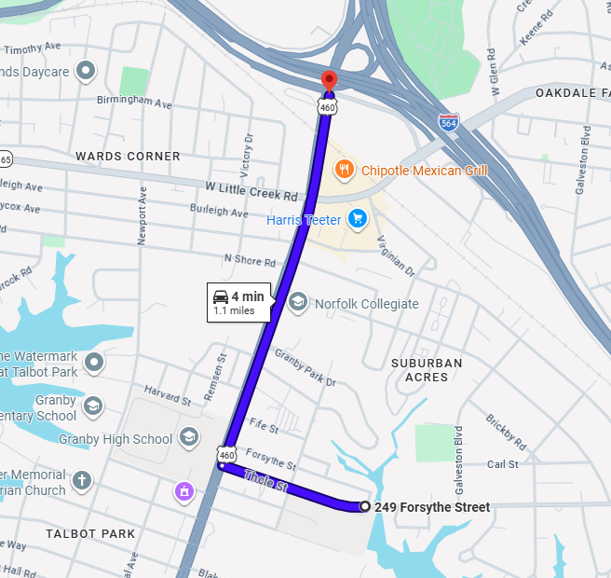

Route 21
Directions to the route:
Start: 7726 Granby St, Norfolk, VA 23505
End: 423 Brackenridge Ave, Norfolk, VA 23505
Time to Destination: 6 min
Distance: 1.6 miles
- Starting at 7726 Granby St, Norfolk, VA 23505 take a right onto E Admiral Taussig Blvd.
- Continue on E Admiral Taussig Blvd for 0.3 miles and take a right onto E Little Creek Road.
- Continue on E Little Creek Road briefly for another 0.3 miles and take a left onto Granby Street.
- Continue back on Granby heading south for 0.7 miles and take a right onto Brackenridge Ave, (this is the first right after passing the Masonic Temple.)
- Take Brackenridge Ave for 0.4 miles.
- The route will begin after the fourth or fifth left (counting the small alley in the middle), onto Catherine Street.
- please activate Go Pro, reduce speed and activate hazard lights.
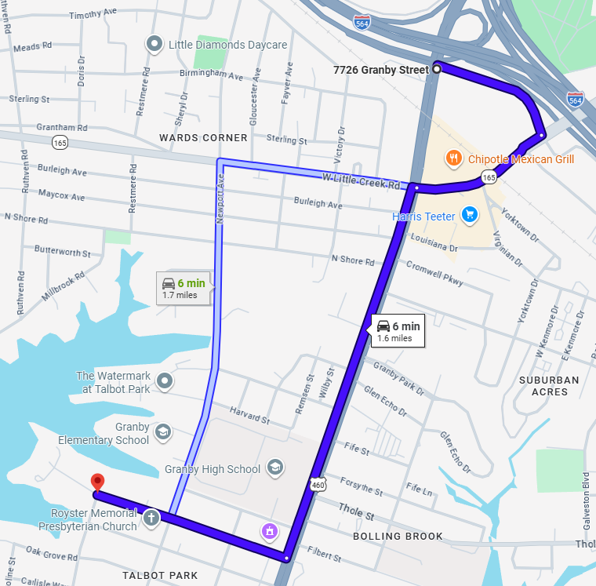
Route 21 cont.
Directions of the route:
Start: 423 Brackenridge Ave, Norfolk, VA 23505
End: 136 Harvard St, Norfolk, VA 23505
Time to Destination: 8 min
Distance: 0.8 miles
- Starting at 423 Brackenridge Ave, Norfolk, VA 23505, take a left onto Catherine Street and continue for 300 feet.
- Turn left onto Sinclair Street and continue for 0.1 miles, then turn left again onto Newport Ave.
- Continue on Newport Ave. for 0.3 miles and take a right onto Warren Street.
- Continue on Warren Street for 0.1 miles and take a right onto Marcy Street.
- Continue on Marcy Street for 350 feet and take a left onto Harvard Street.
- The route ends shortly after turning onto Harvard Street.
- deactivate the GoPro and proceed to the next route.
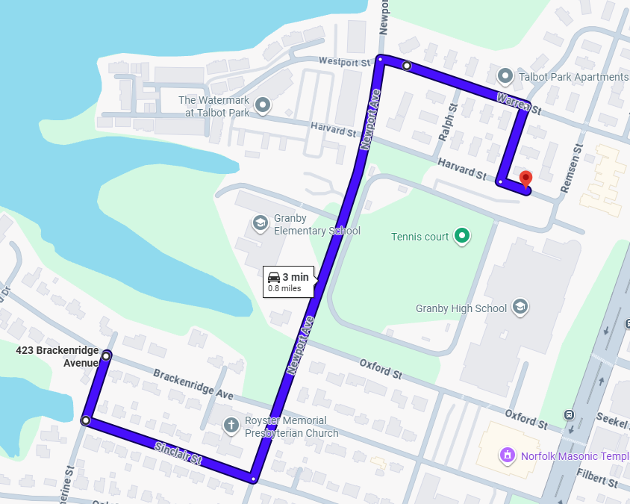
Route 22
Directions to the route:
Start: 136 Harvard St, Norfolk, VA 23505
End: 427 Burleigh Ave, Norfolk, VA 23505
Time to Destination: 7 min
Distance: 0.7 miles
- Starting at 136 Harvard St, Norfolk, VA 23505, continue on Harvard Street for 100 feet and then turn left onto Remson Street.
- Continue on Remsen Street for 300 feet and turn left onto Warren Street.
- Continue on Warren Street for 0.2 miles and turn right onto Newport Ave.
- Continue on Newport Ave. for 0.3 miles then turn left onto Burleigh Ave.
- Continue on Burleigh Ave for 0.2 miles and the route will begin after turning right onto Restmere Road.
- please activate Go Pro, reduce speed and activate hazard lights.
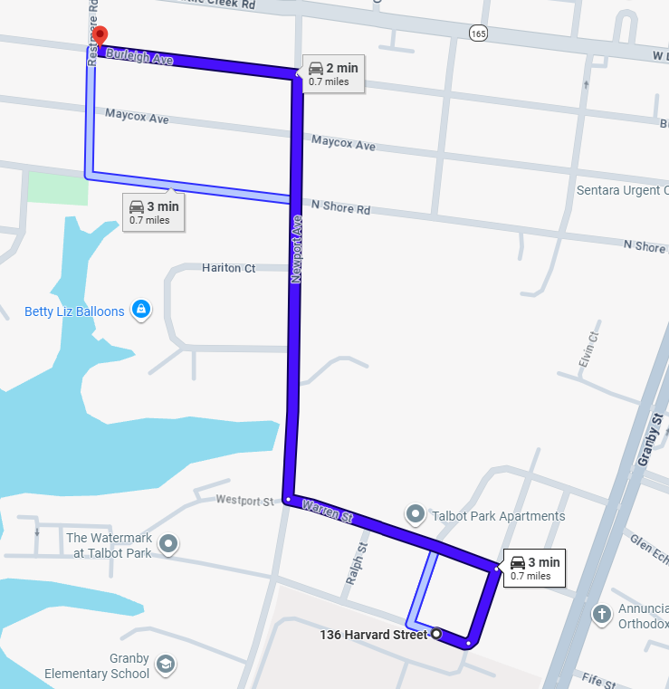
Route 22 cont.
Directions of the route:
Start: 427 Burleigh Ave, Norfolk, VA 23505
End: 942 Armfield Cir, Norfolk, VA 23505
Time to Destination: 8 min
Distance: 0.8 miles
- Starting at 427 Burleigh Ave, Norfolk, VA 23505 immediately turn right onto Restmere Road and continue for 300 feet.
- Take a left onto W Little Creek Road and continue on it for 0.5 miles.
- Take a left onto Armfield Ave after passing Ocean Storage and the Pawn Shop.
- Continue on Armfield Ave for 0.1 miles before turning right onto Armfield Circle.
- The end of the route will be after the first left turn into a parking lot.
- deactivate the GoPro and proceed to the next route.
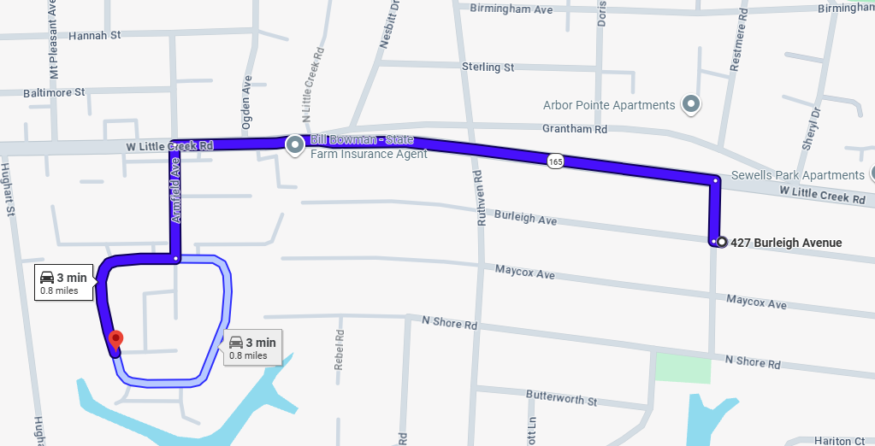

Route 23
Directions to the route:
Start: 942 Armfield Cir, Norfolk, VA 23505
End: 1100 W Little Creek Rd, Norfolk, VA 23505
Time to Destination: 3 min
Distance: 0.5 miles
- Starting at 942 Armfield Cir, Norfolk, VA 23505 make your way around Armfield circle for 0.2 miles before taking a right back onto Armfield Ave.
- Continue on Armfield Ave. for 0.1 miles before turning left onto W Little Creek Road.
- Make sure to get into the right most lane and the route will begin after passing the next intersection at Diven St.
- please activate Go Pro, reduce speed and activate hazard lights.
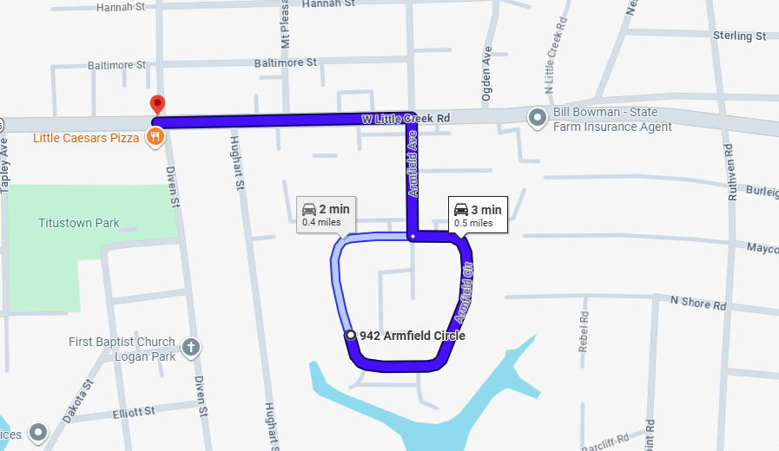
Route 23 cont.
Directions of the route:
Start: 1100 W Little Creek Rd, Norfolk, VA 23505
End: 7600 Hampton Blvd, Norfolk, VA 23505
Time to Destination: 8 min
Distance: 0.8 miles
- Starting at 1100 W Little Creek Rd, Norfolk, VA 23505, continue on W Little Creek Road for 0.8 miles.
- Prepare to take a right onto Hampton Blvd at the intersection.
- The route ends at the intersection with Hampton Blvd.
- deactivate the GoPro and proceed to the next route.
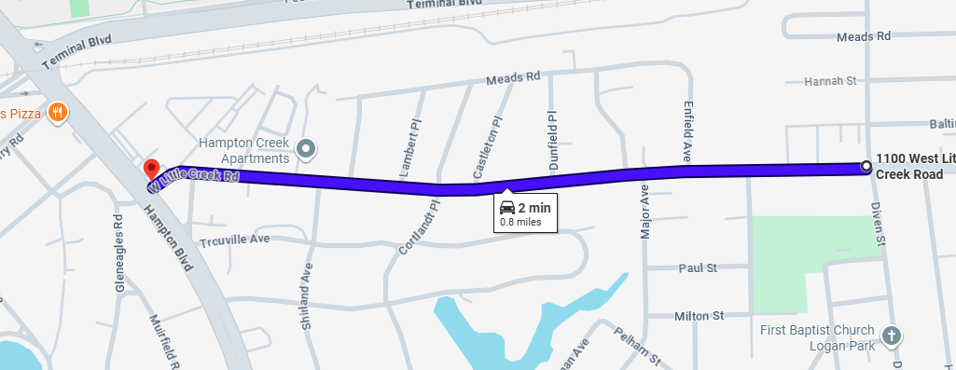

Route 24
Directions to the route:
Start: 7600 Hampton Blvd, Norfolk, VA 23505
End: Hampton & Staff College, Norfolk, VA 23505
Time to Destination: 1 min
Distance: 0.3 miles
- Starting at 7600 Hampton Blvd, Norfolk, VA 23505 take a right onto Hampton Blvd from W Little Creek Road and continue on Hampton Blvd for 0.3 miles.
- The route will begin after passing the entry gates of the Staff college. (There will be a set of lights and to your left you’ll see the Navy Lodge and a large field with dirt on the left.)
- please activate Go Pro, reduce speed and activate hazard lights.
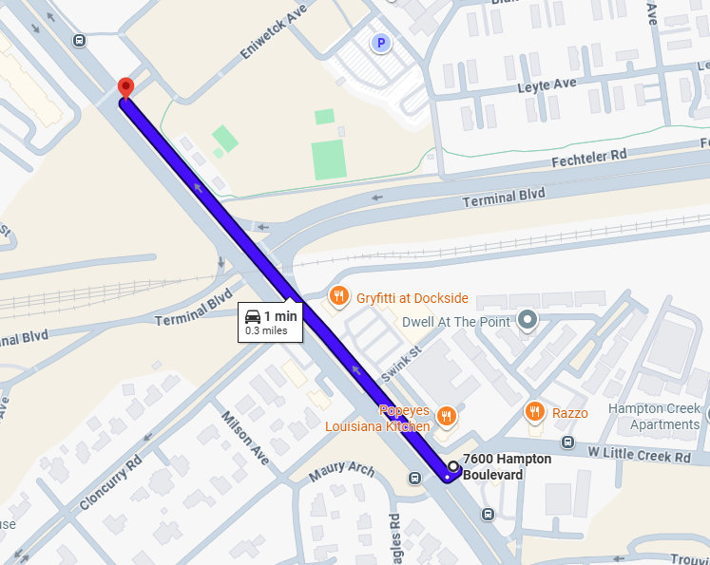
Route 24 cont.
Directions of the route:
Start: Hampton & Staff College, Norfolk, VA 23505
End: 8218 Terminal Blvd, Norfolk, VA 23505
Time to Destination: 7 min
Distance: 0.7 miles
- Starting at Hampton & Staff College, Norfolk, VA 23505 continue on Hampton Blvd for 0.7 miles.
- The route ends after passing Forrest Ave. which is right after Mike’s Pizza on the right.
- deactivate the GoPro and proceed to the next route.
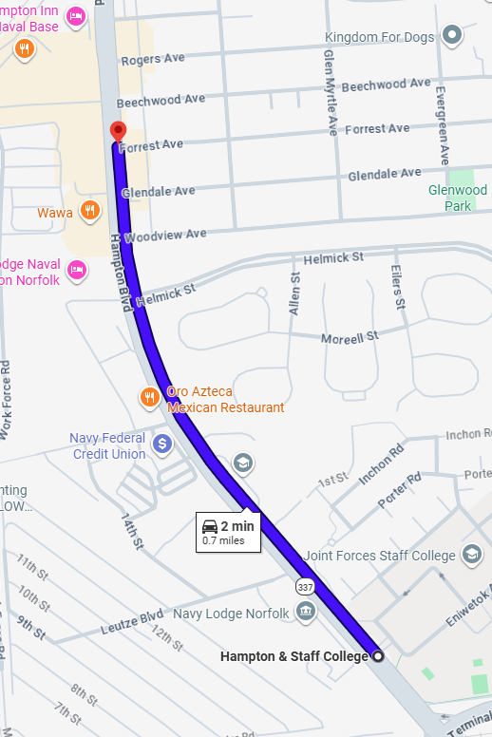
Route 25
Directions to the route:
Start: 8218 Terminal Blvd, Norfolk, VA 23505
End: 8610 VA-337, Norfolk, VA 23505
Time to Destination: 1 min
Distance: 0.2 miles
- Starting at 8218 Terminal Blvd, Norfolk, VA 23505 take Hampton Blvd for another 0.2 miles.
- The route will begin after turning onto Greenbrier Ave. which is the second street after Domoishi on the right, there will be an electrical substation on the left.
- please activate Go Pro, reduce speed and activate hazard lights.
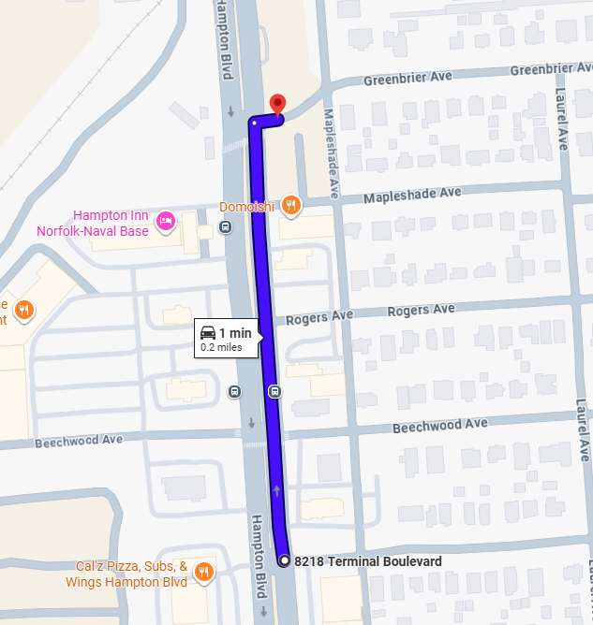
Route 25 cont.
Directions of the route:
Start: 8610 VA-337, Norfolk, VA 23505
End: Kuttin' Edges, 8012 Hampton Blvd, Norfolk, VA 23505
Time to Destination: 6 min
Distance: 0.6 miles
- Starting at 8610 VA-337, Norfolk, VA 23505 continue on Greenbrier ave for 0.1 miles and turn left onto Laurel Ave.
- Continue on Laurel Ave. for 0.3 miles and turn right onto Woodview Ave.
- Continue on Woodview Ave. for 0.1 miles, the route will end before you begin turning left back onto Hampton Blvd to proceed to your next route.
- deactivate the GoPro and proceed to the next route.
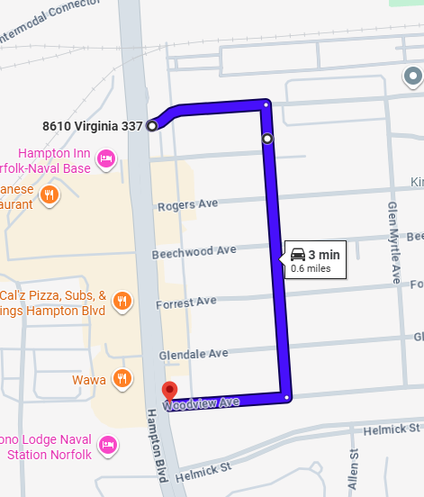
Route 26
Directions to the route:
Start: Kuttin' Edges, 8012 Hampton Blvd, Norfolk, VA 23505
End: 1211 Bolling Ave, Norfolk, VA 23508
Time to Destination: 7 min
Distance: 2.7 miles
- Starting at Kuttin' Edges, 8012 Hampton Blvd, Norfolk, VA 23505 head southward on Hampton Blvd toward Old Dominion University.
- Continue on Hampton Blvd for 2.7 miles.
- The route will begin after passing Bolling Ave.
- please activate Go Pro, reduce speed and activate hazard lights.
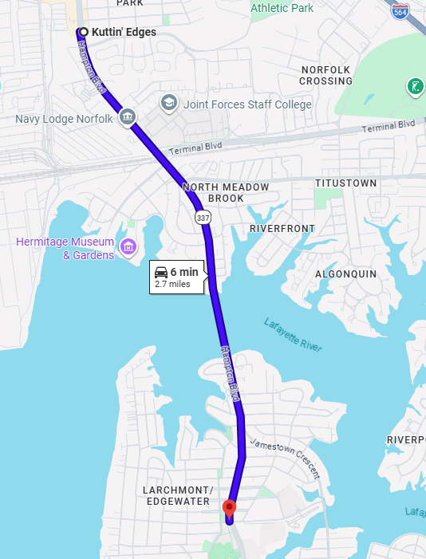
Route 26 cont.
Directions of the route:
Start: 1211 Bolling Ave, Norfolk, VA 23508
End: IBHERT, 4301 Terminal Blvd, Norfolk, VA 23508
Time to Destination: 5 min
Distance: 0.5 miles
- Starting at 1211 Bolling Ave, Norfolk, VA 23508 take Hampton Blvd for 0.5 miles.
- The route will finish before W 43rd Street.
- deactivate the GoPro and proceed to the next route.

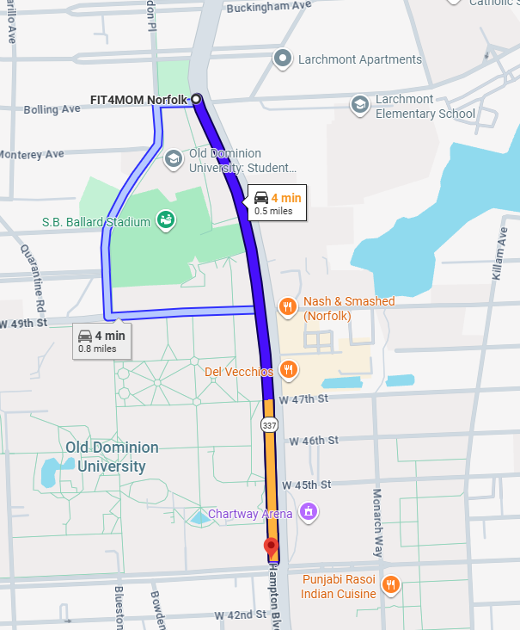
Route 27
Directions to the route:
Start: IBHERT, 4301 Terminal Blvd, Norfolk, VA 23508
End: Elkhorn & 39th, Norfolk, VA 23508
Time to Destination: 4 min
Distance: 0.5 miles
- Starting at IBHERT, 4301 Terminal Blvd, Norfolk, VA 23508 Take Hampton Blvd for 0.2 miles and take a right onto 39th Street(this is the road right after Dunkin Donuts).
- Continue on 39th Street for 0.3 miles.
- The route will begin as you turn right onto Elkhorn from 39th Street.
- please activate Go Pro, reduce speed and activate hazard lights.
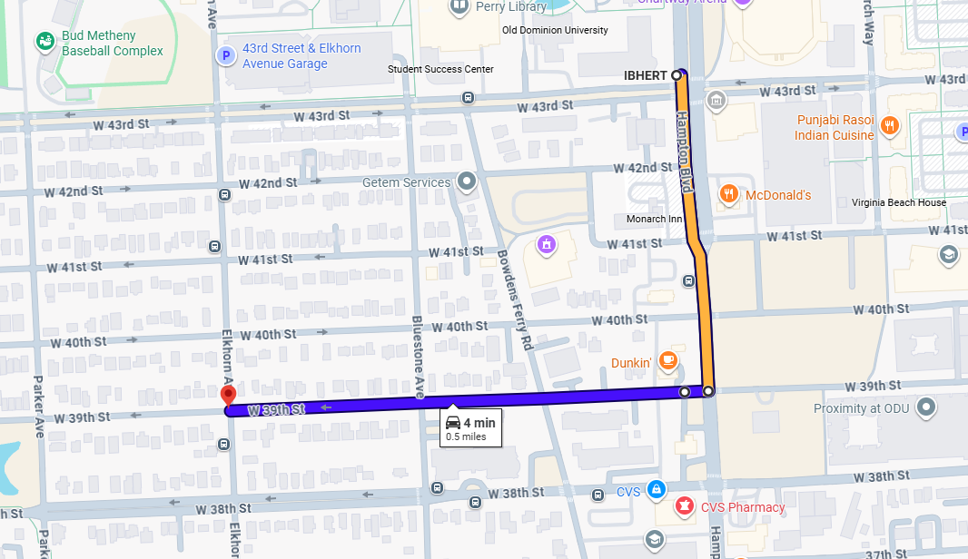

Route 27 cont.
Directions of the route:
Start: Elkhorn & 39th, Norfolk, VA 23508
End: 4003 Bowdens Ferry Rd, Norfolk, VA 23508
Time to Destination: 7 min
Distance: 0.7 miles
- Starting at Elkhorn & 39th, Norfolk, VA 23508 continue on Elkhorn Ave for 0.1 miles and take a left onto 41st Street.
- Continue on W 41st Street for 0.1 miles and take a right onto Parker ave.
- Continue on Parker Ave for 250 ft and take a right onto 42nd Street.
- Continue on W 42nd Street for 0.2 miles and take a left onto Bluestone Ave.
- Continue on Bluestone Ave for 250 ft and take a right onto W 43rd Street.
- Continue on W 43rd Street for 200 ft and take a right onto Bowdens Ferry Road.
- Continue on Bowdens Ferry Road for 0.1 miles and the end of the route is before the turn left onto W 40th Street.
- deactivate the GoPro and proceed to the next route.
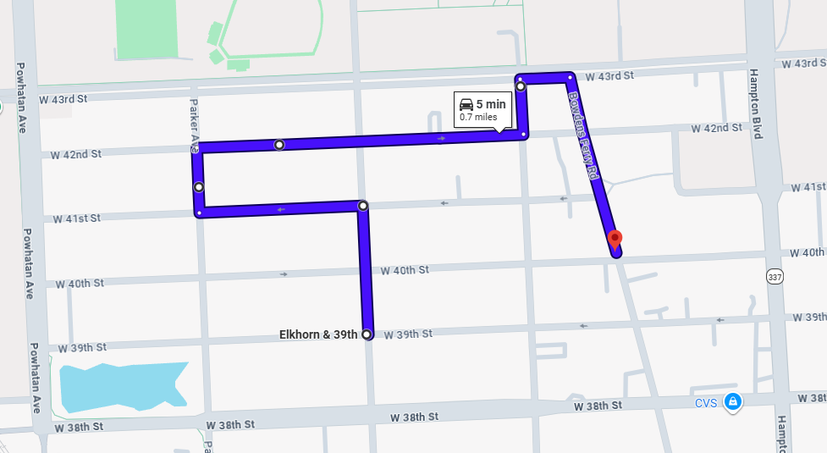

Route 28
Directions to the route:
Start: 4003 Bowdens Ferry Rd, Norfolk, VA 23508
End: 1432 Gates Ave, Norfolk, VA 23507
Time to Destination: 5 min
Distance: 1.1 miles
- Starting at 4003 Bowdens Ferry Rd, Norfolk, VA 23508 take a left onto W 40th Street heading towards Hampton Blvd.
- Continue on W 40th Street for 0.1 miles and take a right onto Hampton Blvd.
- Continue on Hampton Blvd for 0.7 miles and take a right onto Harrington Ave after passing under the railroad tracks, after passing Azalea Court and Woodrow Ave.
- Continue on Harrington Ave for 486 feet and take a slight right onto Gates Ave.
- Continue on Gates Ave for 0.2 miles and prepare to take a left onto Armistead Bridge Road. The route will begin after turning on this road.
- please activate Go Pro, reduce speed and activate hazard lights.
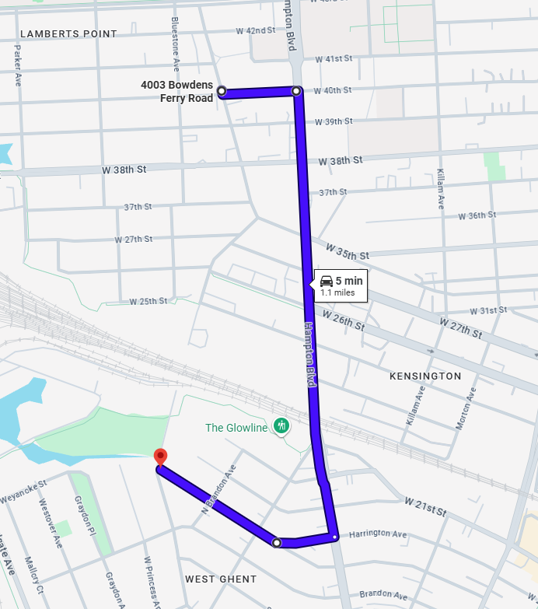
Route 28 cont.
Directions of the route:
Start: 1432 Gates Ave, Norfolk, VA 23507
End: 1200 Spotswood Ave, Norfolk, VA 23507
Time to Destination: 7 min
Distance: 0.7 miles
- Starting at 1432 Gates Ave, Norfolk, VA 23507 turn left onto Armistead Bridge Road from Gates Ave.
- Continue on Armistead Bridge Road for 0.1 miles then take a right onto Old Brandon Ave., then continue on Old Brandon Ave for 0.1 miles.
- Take a left onto Graydon Ave and continue on it for 0.1 miles.
- Turn left onto Langley Road for 300 feet and take a right onto W Princess Anne Road.
- Continue on Princess Anne Road for 300 feet and take a left onto Clarmont Ave.
- Continue on Claremont Ave for 200 feet and take a left onto Armistead Bridge Road.
- Continue on Armistead Bridge Road for 0.1 miles before turning right onto Spotswood Ave, then continue for 400 feet and the Route will end at the first intersection.
- deactivate the GoPro and proceed to the next route.
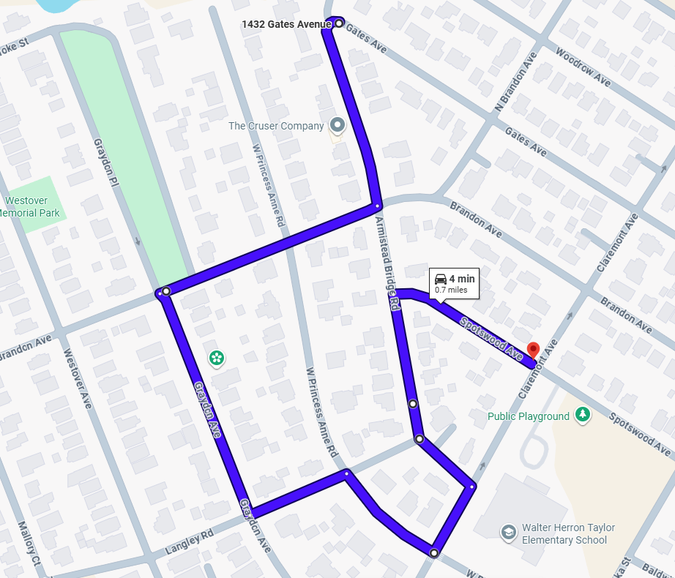
Route 29
Directions to the route:
Start: 1200 Spotswood Ave, Norfolk, VA 23507
End: 826 W Princess Anne Rd, Norfolk, VA 23517
Time to Destination: 2 min
Distance: 0.4 miles
- Starting at 1200 Spotswood Ave, Norfolk, VA 23507 continue on 1200 Spotswood Ave for 500 feet and turn right onto Matoaka Street.
- Continue on Matoaka Street for 0.1 miles and take a left onto W Princess Anne Road.
- Continue on W Princess Anne Road for 0.2 miles and the route will begin after passing through the intersection with Hampton Blvd.
- please activate Go Pro, reduce speed and activate hazard lights.
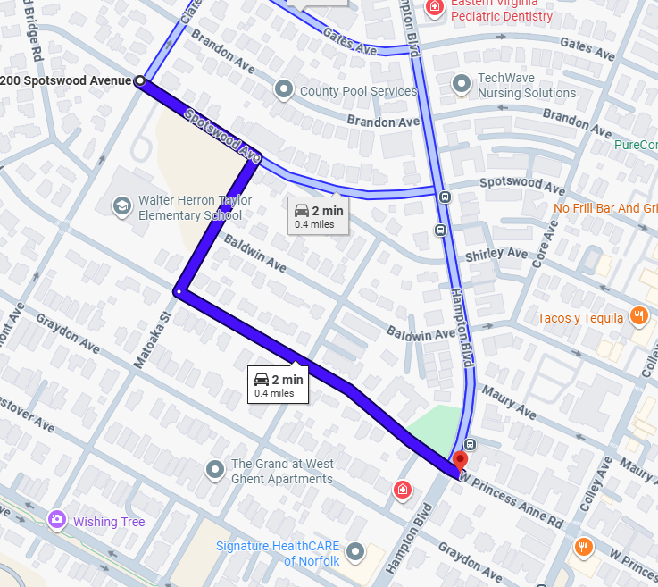
Route 29 cont.
Directions of the route:
Start: 826 W Princess Anne Rd, Norfolk, VA 23517
End: 1201 Llewellyn Ave, Norfolk, VA 23517
Time to Destination: 7 min
Distance: 0.7 miles
- Starting at 826 W Princess Anne Rd, Norfolk, VA 23517 take W Princess Anne Road for 0.7 miles.
- The route will end before the intersection with Llewellyn Ave.
- Prepare to turn left onto Llewellyn Ave. To begin proceeding to the next route.
- deactivate the GoPro and proceed to the next route.
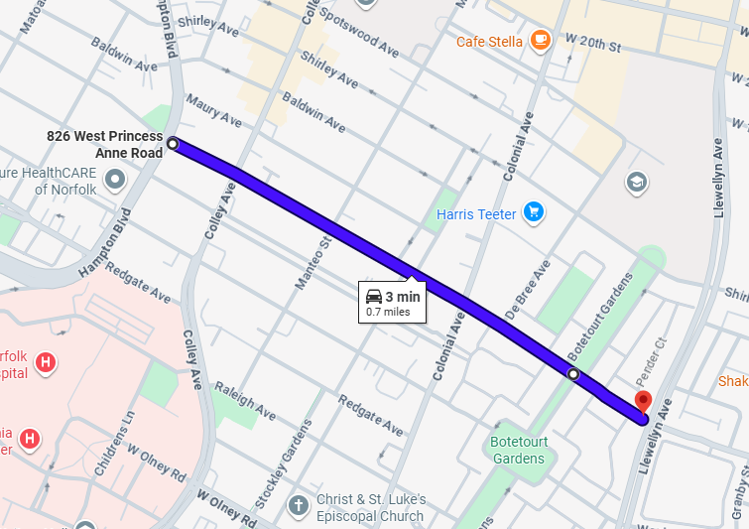

Route 30
Directions to the route:
Start: 1201 Llewellyn Ave, Norfolk, VA 23517
End: 300 W 35th St, Norfolk, VA 23508
Time to Destination: 4 min
Distance: 1.2 miles
- Starting at 1201 Llewellyn Ave, Norfolk, VA 23517 continue on Llewellyn Ave for 1.2 miles.
- Take a left onto W 35th Street. The Route will begin after turning left onto W 35th.
- please activate Go Pro, reduce speed and activate hazard lights.
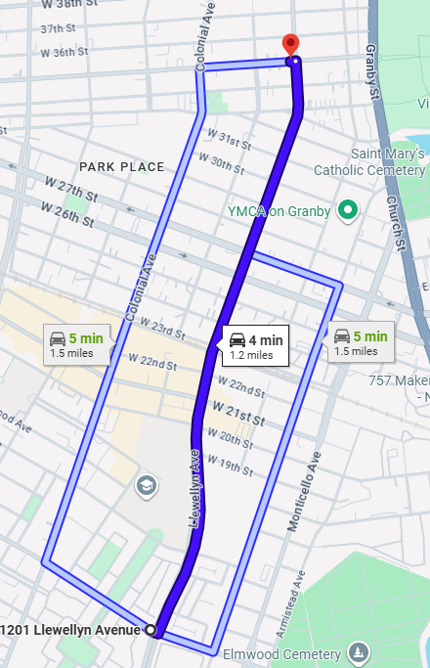

Route 30 cont.
Directions of the route:
Start: 300 W 35th St, Norfolk, VA 23508
End: 3500 Colley Ave, Norfolk, VA 23508
Time to Destination: 5 min
Distance: 0.5 miles
- Starting at 300 W 35th St, Norfolk, VA 23508 take W 35th Street for 0.5 miles.
- The route will end at the intersection with Colley Ave.
- deactivate the GoPro and proceed to the next route.


